RC Baja Racer

By

Chesna Kern
Team member: Gizan Gando

Abstract
The American Society of Mechanical Engineers (ASME) holds a competition at their annual conference for college students to design an RC car that will compete in sprint, slalom, and obstacle course races. The RC Baja car was designed to complete every event in the competition with a focus on the obstacle course due to the anticipated impacts inflicted on the project car by jumps and other obstacles. The project was a collaborative effort. This presentation focuses on the chassis and suspension while Gizan Gando will present about the drivetrain. The drop and frontal impact test requirements guided the design process by providing the parameters that were used to determine size and strength of components. Each component was modeled in SolidWorks during the design period to make sure everything fit properly. During the construction period, all but one of the designed components were manufactured using a 3d printer. Testing involved measuring components to check weight, bending, and clearance as well as frontal impact and drop tests. The drop and impact tests test the strength of the car by submitting it to the forces it would experience by participating in the ASME Baja competition, which includes one and a half foot jumps as well as possible frontal impacts at full speed. The project car was able to withstand a frontal impact at twenty five miles per hour without sustaining damage and being dropped on its wheels from a height of two feet without sustaining damage.
Contents
1. INTRODUCTION 6
a. Description 6
b. Motivation 6
c. Function Statement 6
d. Requirements 6
e. Engineering Merit 6
f. Scope of Effort 6
g. Success Criteria 6
2. DESIGN & ANALYSIS 7
a. Approach: Proposed Solution 7
b. Design Description 7
c. Benchmark 7
d. Performance Predictions 8
e. Description of Analysis 8
f. Scope of Testing and Evaluation 8
g. Analysis 8
i. Analysis 1 8
ii. Analysis 2 8
iii. Analysis 3 9
iv. Analysis 4 9
v. Analysis 5 9
vi. Analysis 6 9
vii. Analysis 7 9
viii. Analysis 8 9
ix. Analysis 9 9
x. Analysis 10 10
xi. Analysis 11 10
xii. Analysis 12 10
h. Device: Parts, Shapes, and Conformation 10
i. Device Assembly 10
j. Technical Risk Analysis 11
k. Failure Mode Analysis 11
l. Operation Limits and Safety 11
3. METHODS & CONSTRUCTION 12
a. Methods 12
i. Process Decisions 12
b. Construction 13
i. Description 13
ii. Drawing Tree, Drawing ID’s 13
iii. Parts 13
iv. Manufacturing Issues 14
v. Discussion of Assembly 14
4. TESTING 15
a. Introduction 15
b. Method/Approach 15
c. Test Procedure 15
d. Deliverables 15
5. BUDGET 16
a. Parts 16
b. Outsourcing 16
c. Labor 16
d. Estimated Total Project Cost 16
e. Funding Source 16
6. Schedule 17
a. Design 17
b. Construction 17
c. Testing 17
7. Project Management 18
a. Human Resources 18
b. Physical Resources 18
c. Soft Resources 18
d. Financial Resources 18
8. DISCUSSION 19
a. Design 19
b. Construction 19
c. Testing 20
9. CONCLUSION 21
10. ACKNOWLEDGEMENTS 22
References 23
APPENDIX A - Analysis 24
Appendix A-1 – Flat Plate Load Analysis 24
Appendix A-2 – Analysis of Front Bumper as a Spring 25
Appendix A-3 – Max Force Absorbed by Suspension 26
Appendix A-4 – Shock K Factor 27
Appendix A-5 – Shock Spring Diameter 28
Appendix A-6 – Suspension Arm Thickness 29
Appendix A-7 – Suspension Arm Pin Size 30
Appendix A-8 – Tower Thickness 31
Appendix A-9 – Suspension Tower Flange Thickness 32
Appendix A-10 – Suspension Arm Pin Size 33
Appendix A-11 – Suspension Arm Fastner Shear Analysis 34
Appendix A-10 – Suspension Arm Fastner Shear Analysis 35
APPENDIX B - Drawings 36
Appendix B – Drawing Tree 36
Appendix B – Full Assembly 37
Appendix B – Chassis and Suspension Assembly 38
Appendix B – Suspension Arm Front Left Subassembly 39
Appendix B – Suspension Arm Front Right Subassembly 40
Appendix B – Suspension Subassembly 41
Appendix B – Chassis Subassembly 42
Appendix B – Suspension Arm Back Left Subassembly 43
Appendix B – Suspension Arm Back Right Subassembly 44
Appendix B – Chassis Plate 45
Appendix B – Suspension Tower 46
Appendix B – Front Bumper 47
Appendix B – Suspension Arm 48
Appendix B – Suspension Fastener 49
Appendix B – Steering Block 50
Appendix B – Steering Block Support 51
Appendix B – Suspension Arm Right 52
Appendix B – Steering Block Support Left 53
Appendix B – Back Axle Support 54
Appendix B – Steering Block Support Back Right 55
Appendix B – Steering Block Support Back Left 56
Appendix B – Bottom Cover 57
APPENDIX C – Parts List and Costs 58
APPENDIX D – Budget 59
APPENDIX E - Schedule 60
Appendix F – Expertise and Resources 62
APPENDIX G – Testing Report 63
Appendix H – Resume 64

1. INTRODUCTION

Description
The goal of this project was to build an RC car that would be successful in the ASME RC Baja competition. Success was defined as completing all events of the ASME RC Baja competition. RC cars contain key elements of full size cars like suspension, differentials, and an energy source, which made this project valuable for students planning to make their careers in the automotive industry. The ASME RC Baja competition also provided a basic framework for the project with a competition at the end that provided a means of evaluation as well as something to look forward to while completing the project.

b. Motivation
The CWU ASME club has a rich history of competing in the RC Baja competition. Because the competition was fundamentally a test of engineering skill, it required the same design, build, and test periods demanded by the senior project class. The rules of the competition provided a solid framework for a successful senior project. The project was also easily divided into two key aspects, the chassis and drivetrain. This encourages students to form teams. The teamwork aspect was very important as projects in industry are usually assigned to a team, rather than an individual, so students were better prepared for the workforce by working in teams.

c. Function Statement
The function of the chassis was to provide support for all of the components of the car as well as the basic structure of the car that the other components were attached to, and the function of the suspension was to protect the drivetrain of the car by absorbing harsh impacts.

d. Requirements
The project had to meet ASME competition guidelines as well as the following.
- The chassis must weigh less than four pounds.
- The car must be able to withstand a two foot drop.
- The suspension must have one and a half inches of free movement.
- The chassis must support drivetrain components up to five pounds without bending.
- The car must sustain a frontal impact of thirty miles per hour without breaking.
- The car must be able to turn within a three foot radius.

e. Engineering Merit
This project required analysis using statics and strength of materials. Statics was used to determine loadings on components as well as maximum bending moment for beam like components. Strength of materials was applied to determine the stresses in components due to loadings as well as the thickness and types of materials used.

f. Scope of Effort
The scope of this project was limited to the chassis and suspension of the car. This included all parts related to suspension as well as the basic structure of the car, like the chassis plate. The drivetrain was designed and produced by the other team member.

g. Success Criteria
This project was evaluated by its ability to compete in all aspects of the ASME RC Baja competition. These aspects included the sprint, slalom, and obstacle course. The project would have been successful if it could compete in every event and unsuccessful if it could not.

2. DESIGN & ANALYSIS

a. Approach: Proposed Solution
The RC Baja project was chosen because, of the four available projects, it was most applicable to a career in the automotive industry. The project design was based on cars that were successful in the RC Baja competition in previous years. This included a light, strong chassis, big wheels, and narrow overall shape. After looking at previous year’s designs, the decision was made to 3-d print as much of the project as possible to save weight and make the car faster.

b. Design Description
Figure 1:Initial Design
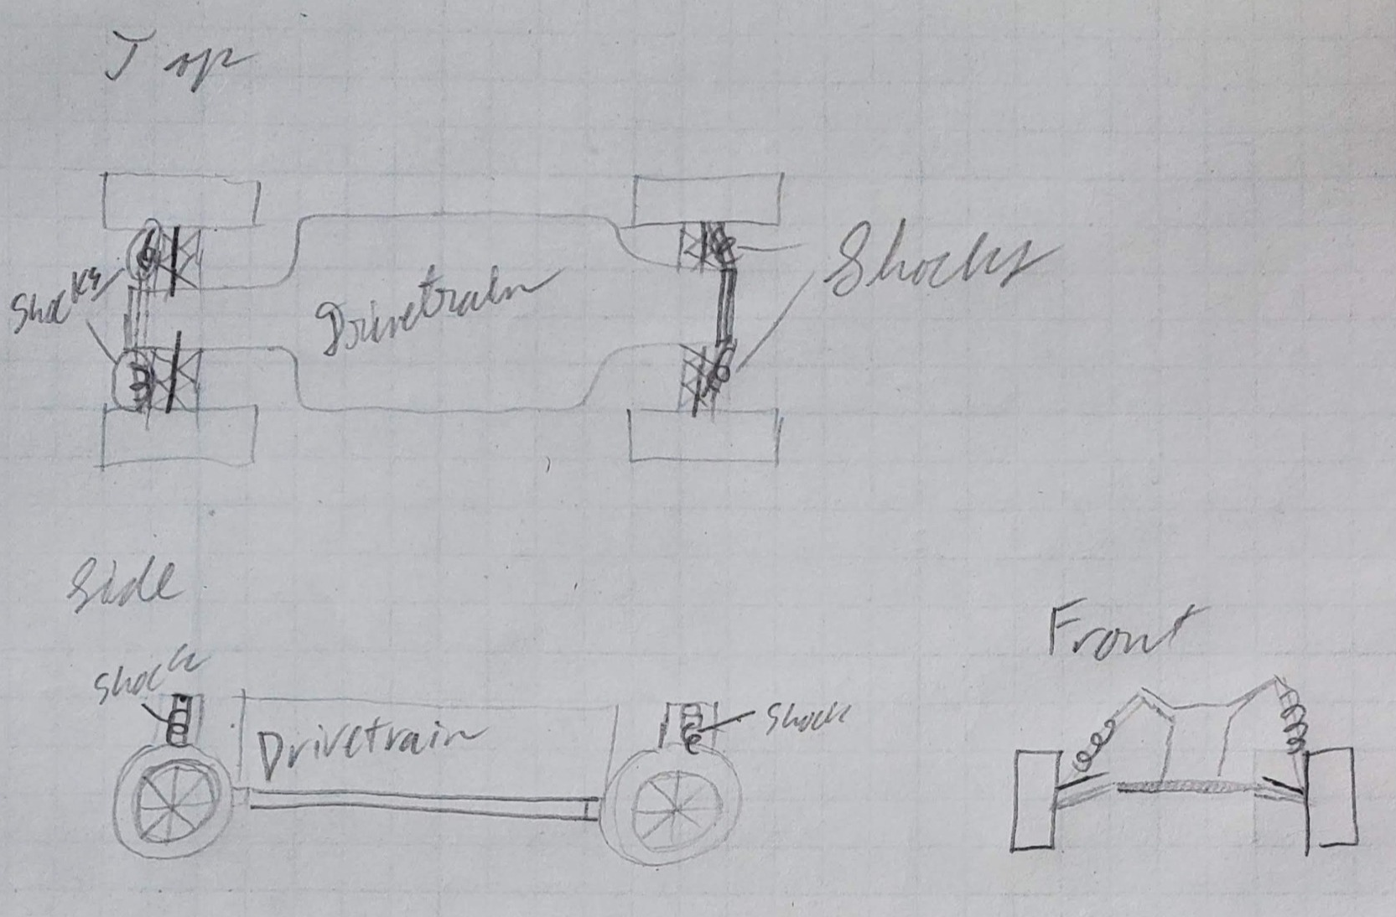
The basic design of the chassis was a rectangle with tabs to attach the suspension, and suspension arms as seen in figure 1. These components were all bolted to the chassis plate along with a front bumper which was added later. The simple shape left plenty of space in the middle for the drivetrain components, designed by the other team member.

c. Benchmark
The Axial RC Jeep Wrangler Unlimited Crawler is a well-reviewed RC car designed to overcome obstacles similar to the course created for the ASME RC Baja competition. The Jeep has a steel construction and large grippy tires that are excellent for use on trails. Due to the lighter construction of the project car, it was not able to handle as big of obstacles as the Jeep, however, the project car was designed to perform well in a sprint where steel would slow it down. The grippy tires of the Jeep would also be a detriment to the sprint portion of the competition, so the project car has smaller tires with less grip to balance the requirements of obstacle course and sprint.

d. Performance Predictions
The car reached a top speed of 25 mph. It also withstood a frontal impact of 25 mph without showing signs of damage.

e. Description of Analysis
The analysis of the chassis included statics, dynamics, and strength of materials all focused on different loads and stresses the suspension and chassis underwent. Strength of the materials used for this project was key and analysis of frontal and wheel impacts determined the specs of the front bumper and the strength of the suspension. Flexure analysis of a flat plate determined the thickness of the chassis plate. The requirements specify the chassis must support the drivetrain components (weighing up to five lbs.) without bending. Flexure analysis was performed and the plate was determined to be a minimum of 0.024 inches (more information in the analysis 1 section below). The nearest standard size for sheet acrylic was 1/8 inch, so that size was chosen initially. The thickness of the front bumper in front of the chassis plate was also determined through analysis (more information under analysis 2). The maximum speed of 30 mph given by the designer of the drivetrain was used in the conservation of energy equation. Work energy was then used to find the thickness of material needed, which was 0.6 inches. This calculation helped to optimize the design by making the bumper as small as possible while still protecting the car.

f. Scope of Testing and Evaluation
The main evaluation of the car came during the ASME RC Baja competition, as the success criteria defined in the introduction depends on the car completing all events of the competition. In addition to the competition, the car was also run into a wall to evaluate its ability to survive a frontal impact, dropped on its wheels to determine its ability to survive a drop, the suspension was measured to ensure it meet the requirement from the introduction, and the chassis and wheels were weighed to make sure they met requirements as well. A finite element analysis of the front bumper was also performed and compared to results from running the car into a wall.

g. Analysis
This section details the component analysis for the chassis.

i. Analysis 1
Flat plate analysis was applied to the chassis plate to determine the thickness needed. The maximum weight of the drivetrain components mounted to the chassis plate was 5 lbs. To have a factor of safety of 1.5, the chassis plate was designed to support 7.5 lbs. The calculations shown in appendix A-1 determine the necessary thickness of the chassis plate through bending analysis of a flat rectangular plate. The calculations indicate that a thickness 0.024 inches is required.

ii. Analysis 2
The maximum top speed of the car is 30 mph which would cause significant damage to the car if it were to run into a wall at top speed. This calculation determined the required thickness of a bumper using conservation of energy. The bumper was assumed to be made of ninjaflex with a width of three inches and a height of one inch and to act as a spring. The tensile modulus from the material spec sheet was used to find the approximate k factor of the material. The k factor was used to determine the force that the bumper could absorb. Then conservation of energy was applied, and it was determined that a 0.6 inch thick bumper could absorb the impact.

iii. Analysis 3
The requirements specify that the car must survive a two foot drop when landing directly on its wheels. These calculations determined the force the car experiences as a result of the drop as well as the force to be absorbed by each shock using conservation of energy and the work equation. The calculations show a force of 27 pounds exerted on each wheel, assuming symmetrical loading.

iv. Analysis 4
This analysis took the force determined in analysis three and used Hooke’s law to determine the spring constant necessary to absorb a 27 pound force applied to each wheel. The result of this analysis was used to determine the necessary coil diameter for each shock.

v. Analysis 5
This analysis took the spring constant determined in analysis four and used in the equation $K=\frac{Gd^{4}}{8nD^{3}}$ where K is the spring constant, d is the estimated diameter of the wire that makes up the spring, n is the number of coils, and D is the diameter of the coils. Assuming that the spring is made from steel, is three inches long, and has 18 coils, the minimum spring diameter comes out to be 0.034 inches. All assumptions were based on a shock from a previous year found in the senior project room.

vi. Analysis 6
Analysis three determined the drop force on each wheel to be 27 pounds of force. Analysis five used this information to determine the necessary thickness of a suspension arm made from ABS. The length of the suspension arm was determined to be 2.5 inches because a shorter length would have the chassis interfere with the wheels. The maximum bending stress of the suspension arm was assumed to be equal to the flexural yield strength of ABS found on Matweb. The bending stress equation was then applied to find the minimum thickness of the suspension arm to equal 0.0075 inches.

vii. Analysis 7
This analysis determined the necessary diameter of the pin section of the suspension arm using shear stress. A safety factor of 1.5 was applied to the max shear force of ABS (Matweb) making the design stress 1000 psi. The diameter was then found from the equation $τ=\frac{F}{2τ_{design}}$. Force was taken to be the drop force per wheel from analysis three and was divided by two because the force is divided between two pins on either side of the arm. The minimum diameter was found to be 0.13 inches.

viii. Analysis 8
Analysis eight used beam bending to determine the necessary thickness of the suspension tower. The force (assumed to be equal to drop force from analysis three) was assumed to only act on the top flanges of the tower. For this reason, the flange was analyzed as a beam. First, the reactions on the tower side were determined using statics and represented on a free body diagram. Then maximum moment was determined by drawing shear and moment diagrams. From there, minimum thickness was determined to be 0.0094 inches from the stress equation $σ=\frac{Mc}{I}$.

ix. Analysis 9
Once again the drop force from analysis three was used to determine the necessary thickness of the flange of the suspension tower. First a free body diagram was used to determine the location of the forces, then a shear diagram was used to determine maximum shear, and a moment diagram was used to determine the maximum moment. Finally, the stress equation $σ=\frac{Mc}{I}$ was used to determine the minimum thickness to be 0.133 inches, which was rounded up to 0.2 inches to simplify dimensions.

x. Analysis 10
Once again the drop force from analysis three was used to determine the necessary thickness of the flange of the suspension tower. First a free body diagram was used to determine the location of the forces, then a shear diagram was used to determine maximum shear, and a moment diagram was used to determine the maximum moment. Finally, the stress equation $σ=\frac{Mc}{I}$ was used to determine the minimum thickness to be 0.133 inches, which was rounded up to 0.2 inches to simplify dimensions.

xi. Analysis 11
The ABS suspension fasteners were predicted to carry the largest stress in the round hole, so this analysis determined the thickness of material surrounding the hole. Using the equation $σ=\frac{Mc}{I}$ and taking the force to be the drop force from analysis three, the thickness was determined to be 0.00675 inches.

xii. Analysis 12
This analysis used shear stress to determine the minimum diameter for the pins used to hold the front bumper to the chassis plate. The yield stress of steel was determined to be 36000 psi from Hibbler’s statics. The force acting on the pins was assumed to be equal to the impact force found in analysis two. Then the equation $τ=\frac{F}{A}$ was used to determine the area to be 0.075 inches. Finally, the area was used to determine the diameter of the pins to be 0.309 inches.

h. Device: Parts, Shapes, and Conformation
The shapes of the parts were kept as simple as possible in order to make them easy to analyze and build. Sharp corners were generally filleted to reduce stress concentrations, but this was not seen as necessary on the suspension arm or suspension arm fasteners. The suspension arm was not filleted because the force from impact was transferred to the suspension arm via the steering block and then was absorbed by the suspension, meaning that corner fillets on would not make a difference to the force concentrations. A general safety factor of 1.5 was applied to everything in the car to keep it light while still allowing a margin of error. Aerodynamics at the speeds that the car travels at were not a huge factor, but if they were, this car would be less aerodynamic than a semi-truck. Every component is blocky and there is no cover on top to divert airflow over the car.

i. Device Assembly
Most of the components of the assembly were attached to the chassis plate, so it was long and wide to allow plenty of space for the drivetrain. To provide proper support for the drivetrain and other components, the chassis plate was designed to support the maximum load exerted by the drivetrain components without bending. To prevent the drivetrain from being damaged by wheel impact, coil suspension was added to both ends of the car, with each shock being analyzed to ensure the suspension could absorb the maximum impact described in the requirements (a two foot drop). The general device assembly was kept simple to save weight and ensure ease of assembly. Saving weight was very important as the chassis and suspension assembly were limited to a combined weight of four pounds by the requirements. The assembly consisted of a chassis plate with a bumper on the front, two suspension towers with shocks (one at each end), and four suspension arms branching off the sides which were bolted to the chassis plate on one side and the shocks on another. A bottom cover was also attached near the back of the chassis plate to cover the hole in the chassis plate that was cut to make room for part of the gearbox to lower the back axle in relation to the chassis plate.

j. Technical Risk Analysis
The technical risk all depends on the strength of the components. Most components were analyzed to be sure that they would be large enough to not break under the loads exerted by the requirements, but a safety factor of just 1.5 was applied to the entire car. So, if any calculations were wrong, many components could break. The risk of using the smallest allowable components is that they could break if they experience loads greater than the calculated ones or if loads are applied in a different direction than calculated.

k. Failure Mode Analysis
All of the bolts (analyzed as pins) experienced shear loadings that were dynamic but were analyzed as static because only the maximum loads were known. Similarly, the arms of the suspension tower and the bottom of the suspension tower were analyzed as beams under static loading. A safety factor of 1.5 was applied to every component so that even if the calculated loads were smaller than the actual loads experienced by the car, it would still hold up.

l. Operation Limits and Safety
The chassis was designed to be four pounds with a five pound drivetrain sitting on top of the chassis plate. This maximum weight of nine lbs. was then used to calculate the maximum forces experienced by the car when dropped and run into a wall at a maximum speed of 30 mph. Because the car was designed to operate at the limits in the requirements, it should not be jumped higher than two feet or operate at speeds faster than 30 mph. At higher speeds and longer distances, the car will break.

3. METHODS & CONSTRUCTION

a. Methods
The biggest problem was making sure that every component would be able to withstand the force from the drop test. To overcome this, statics and strength of materials were applied to many components. The most used equation was the bending stress equation $σ=\frac{mc}{I}$. This was because the maximum stress is when the material will break and therefore the factor that controls the size of the parts. This equation was used many times to optimize the parts by calculating the minimum size of a component, making it lighter. For most of the calculations one or two dimensions were dictated by the geometry of other parts, one example being the suspension tower, which had to fit between the suspension arm fasteners so the shocks would align properly. Then the final dimension, usually thickness, would be dictated by the calculations. This method allowed the parts to be large enough to serve their purpose and be strong, while keeping lightness at the forefront. This focus on lightness was important so the car would perform well during the sprint. The benchmark car chosen in section 2c had a steel chassis, so it can withstand higher stresses generated by greater loads from heavy components or the shock of an impact. However, the acrylic chassis of the project car is lighter, therefore allowing it to perform better in the sprint portion of the ASME RC Baja competition.
Nearly all parts were 3d printed, because parts with visible defects could be easily reprinted and the process could be closely monitored. The reproducibility of parts was extremely important for this project as many parts needed to be changed based on purchased part dimensions or updates to the drivetrain assembly that were unavailable during the initial design process in the fall. Even though a preliminary design was finished by the end of fall quarter, the chassis and drivetrain assemblies did not match up well, indicating some redesigning would be necessary during the construction process in the winter. Between issues with the drivetrain and poor design choices discovered after manufacturing, five new parts were added, and every part designed in the fall had to be updated. To avoid schedule issues caused by new and redesigned parts, all parts were printed from the fall quarter designs by the third week of winter quarter. The time between the first manufacturing deadline (Mfg01 on the class schedule) and the end of week eight was all allowed for altering parts. All this time was needed, so the chassis plate could not be cut out until the end of week eight. The week eight deadline for part changes was made to prevent team members from falling behind and to make time allowances for assembly before the class deadline during finals week.

i. Process Decisions
Initially all parts (except shocks and wheels) were going to be 3d printed. The chassis plate ended up being too big for any 3d printer the team had access to. The only other process in Hogue that could produce similar results was the laser cutter, however the chosen material (ABS) cannot be used in a laser cutter as it produces a bad finish as well as cyanide. This caused the team to switch to acrylic, which had similar enough properties to ABS to still serve the purpose of the chassis plate, but would produce a nice finish when using a laser cutter. The process can be monitored, the bed is big enough to accommodate the chassis, and can precisely produce parts. The design was optimized with multiple analyses. The analyses determined the minimum thickness or diameter of every part. This ensured that each part could withstand the forces exerted on them while not being unnecessarily large. An example of this is in analysis eleven where the minimum thickness of the material around the hole for the suspension arm pins was determined.

b. Construction

Description
All of the components were manufactured outside of CWU. Of these manufactured parts, all except for the chassis plate, which was laser cut, were 3d printed using ABS or ninjaflex. The pieces like the suspension arms and surrounding parts were printed first to allow for multiple iterations to be created. This was important because design mistakes were discovered during printing that would otherwise have gone unnoticed. An example of which was the original suspension arm only had two bolt holes to connect the steering block support. Once the parts were printed and assembled, it became clear that two bolts allowed for an unacceptable amount of bending in the steering block support, causing a third to be added to the design. The chassis plate was cut last to ensure that only one iteration of the part needed to be manufactured. Once all parts were manufactured the smaller assemblies were put together. This includes each suspension arm assembly and the suspension tower with shocks. These assemblies were added to the chassis plate followed by the front bumper, bottom cover, and drivetrain.

Drawing Tree, Drawing ID’s
The drawing tree in appendix B shows how all the parts went together. The tree shows the highest level divided into a chassis and drivetrain assembly. This was because this section of the project only pertains to the chassis and suspension. Below that are the suspension arm front and back assemblies, chassis plate, suspension assembly, front bumper, wheels, and bottom cover. The suspension arms each had a separate assembly because the back suspension arms needed to provide better support for the axles than the front as the car was back wheel drive necessitating the creation of the back axle support. The axle support part was not added to the front of the car, because the front axles needed to be able to turn to steer the car. In addition to the different parts required for the front and back suspension arm assemblies, the suspension arm assemblies on the left and right must be mirror images of each other for the connection to the shocks. These assemblies contained the suspension arm, steering block, steering block support, back axle support (back only), and suspension arm fasteners. The suspension tower had its own assembly as well because the shocks were attached to the tower before anything else. The chassis plate was the most important part because everything was built on it. The suspension arm fasteners, suspension tower, bottom cover, and front bumper were all directly attached to the chassis plate as well as all of the drivetrain parts.

Parts
The shocks were purchased from Amazon and the wheels were donated by ASME. Manufactured parts were laser cut and 3d printed. The chassis plate was laser cut from acrylic. The front bumper was 3d printed using ninjaflex and the shock towers, suspension clips, suspension arms, steering blocks, and steering block supports were made from ABS. The fasteners that held everything together were machine screws with three different thread sizes (4-40, 8-32, and 10-32) with appropriate nuts, and ¼-28 hex bolts for the front bumper.

Manufacturing Issues
Both laser cutting and 3d printing have drawbacks. Laser cutting is a subtractive process so more material must be purchased than will be used for the final part, and laser cutters only work on certain materials like acrylic. 3d printing can be a long process and the parts can have rafting that is hard to remove and print errors like lifting from the print platform or uneven texture are not uncommon. However, most of the support material/rafting could be removed with a putty knife, small screwdriver, and occasionally a disk sander. Parts with uneven texture or lifted edges were reprinted to correct the dimensions. To triple check the size of the chassis plate two prototypes were laser cut before the final part was even started.

Discussion of Assembly
The assembly was first divided into the drivetrain subassembly and the chassis subassembly. The chassis subassembly was based around the chassis plate with the suspension tower, suspension arm subassemblies, bottom cover, and front bumper attached to it. The suspension arm subassemblies were based around the suspension arm with the suspension arm fastener connecting the arm to the chassis, the steering block mounting on the arm and attaching to the axel and the wheel. The steering block or back axle supports were also held in place with the steering block support above the block. The shocks attach to the suspension tower and the suspension arm.

4. TESTING

a. Introduction
The requirements for the car tested with a simple measurement were to support the drivetrain without bending, the suspension must have one and a half inches of free movement, and the chassis must weigh less than four pounds. The more complicated testing was for dropping the car on its wheels from a height of two feet, testing the bumper by dropping it at a height to approximate the force exerted by a 30 mph impact, as well as testing the turning radius of the car.

b. Method/Approach
Most of the testing was simple. The chassis parts were put on a scale to evaluate the weight and the suspension was measured with a measuring tape to ensure one and a half inches of free movement. To perform the drop test, a speed test was to be performed first to check the performance of the car. The gearbox of the car was not working when the second drop test was run, so the performance test portion was dropped. Then the car was dropped on its wheels from a height of two feet and a visual inspection was performed to make sure nothing had moved. After the visual inspection, another performance test was done to make sure nothing internal was damaged as long as the drivetrain was working before the test. The frontal impact test was performed with a speed test before and visual inspection and speed test as well. Originally, the car was going to be driven at top speed into a wall to test the front bumper, but due to issues with the drivetrain the car could barely attain 5 mph. To simulate a frontal impact at the 30 mph that the bumper was designed for, the car was wrapped in bubble wrap and dropped from a height of 30 feet onto the bumper to simulate a 30 mph impact. The fourth requirement was tested by fully assembling the car then measuring the distance between a flat surface the car was sitting on and the bottom of the chassis plate at each wheel and in the center of the chassis plate to ensure there was no bending. The final requirement was that the car be able to make turns with less than a three foot radius. This test was performed by using painter’s tape to mark a three foot circle on the floor of the Fluke lab. The car was then driven into the circle and turned around without touching the tape.

c. Test Procedure
Once all the parts for the chassis had been obtained, they were placed together on a scale to ensure a weight of less than four pounds. The bending of the chassis plate was checked by placing the car on a flat surface and measuring the distance between the surface and bottom of the chassis plate with a tape measure. To check the suspension movement, each of the four shocks was measured with a measuring tape to ensure one and a half inches of free movement. A speed test was run before the drop test to test the performance of the drivetrain. This portion of the procedure was dropped, however, when the drivetrain of the car was not operational. The frontal impact test was conducted in the same place as the drop test (the Fluke lab where the tape was still on the wall from drop testing) because the car was dropped from a height of 11 inches onto its bumper to simulate an impact at 30 mph, a speed that the car could not get close to while driving. The eleven inch drop was an initial test that was supposed to be followed by a 30 foot drop, but this was not done because the car failed the first test. After the crash, the car was visually inspected, and another speed test was run to make sure the car performed the same before and after crashing. The drop test required a tape measure and a flat space to drop the car. A speed test was run to check performance, depending upon the functionality of the gearbox, then the car was dropped on its wheels from a height of two feet, and a visual inspection performed, followed by a speed test to ensure the car was the same before and after. The speed test afterward was unnecessary for the first two trials of the drop test as the car failed both times. To test turning radius, a three foot circle was made on the floor of the Fluke lab with painter’s tape. Then the car was driven into the circle and turned around without the wheels touching the tape.

d. Deliverables
The tests performed with just a tape measure or scale were documented with pictures and the results recorded on green sheets. The more complicated tests had forms made before the tests with spaces for all the data that was to be taken. This includes top speed of the car before and after the test, force of impact, and pass/fail for the requirement. The car was predicted to survive both the drop and wall impact tests. However, when the drop test was first performed, the chassis snapped and on the second attempt one of the suspension arms broke.

5. BUDGET

a. Parts
Nearly all of the parts were made from ABS using a 3D printer or acrylic using a laser cutter. The few parts not manufactured were ordered from Amazon (shocks), donated by ASME (wheels), or were fasteners purchased at Ace Hardware. The chassis plate (part 20-001 in Appendix C) was the most expensive part. In order to reduce costs, all custom parts were manufactured locally.
The project is significantly under budget mostly because the wheels, which would have been the most expensive part of the project, were donated by the ASME club. Only half of the project budget was used. Because the 3d printed parts all came from a roll of filament bought for the project, additional prints due to error did not increase the cost of the project. All of the purchased parts were either bought in person or from Amazon with Prime so there were no additional shipping costs.
Had the wheels not been donated by the ASME club, they would have been the most expensive parts on the car, so not needing to buy these drastically reduced the cost of the project. The shocks were less expensive than the roll of filament for the 3d printed parts, but at about $5.50 per shock, they were a major contributor to the cost of the project. Nuts and bolts were the smallest contributor to the budget at less than $10 combined.
All material, the shocks, and all nuts and bolts for the chassis have been purchased. Most purchases went smoothly like the sheet plastic for the chassis plate, which the team had by the end of the second week of class, which lines up well with the proposed timeline (order in January). The shocks also arrived on time (within the first two weeks of class) but had to be returned and repurchased because the original set were bent. This caused a slight delay, but measurements were taken from the bent set to redesign parts like the shock tower and the replacement parts had arrived by the time the reprints were finished.

b. Outsourcing
The 3d printed and laser cut parts were manufactured at Thorp High School. There was no additional cost associated with this manufacturing decision.

c. Labor
All design, assembly, and any finishing processes were performed by team members. This allowed money that may have been spent on outside labor to be spent on extra nuts and bolts in case some got lost during assembly.

d. Estimated Total Project Cost
The ASME RC Baja rules specify a budget of four hundred dollars to be divided between the chassis and drivetrain. Parts were the biggest cost for the project totaling about $140 not including the raw material that was not used for parts. Shipping costs were nonexistent as any from Amazon had free shipping and any other ordered parts were picked up in person.

e. Funding Source
The funding for this project was all out of pocket. The budget was divided between the team.

6. Schedule

Design
The basic design process of the project was finished before winter break (November 20, 2020). The budget and project were both determined during week one. The introduction was finished in week two and the analysis was started in week three finishing in week ten. Part drawings were completed between weeks five and ten. The introduction, design and analysis sections of the report were done by week six. The first analysis to be done was the chassis plate, followed by the front bumper, and suspension related analyses. The suspension of the car had many components so nearly every analysis from week three to ten was related to the suspension as seen in the Gantt chart. The discussion and conclusion were written in week ten. The first full version of the report, which contained all information relating to the design portion, was due Tuesday of finals week (November 17, 2020).

b. Construction
To avoid a time crunch in the final weeks of the project, as much manufacturing as possible was done within the first four weeks. Any parts not purchased were 3d printed, except for the chassis plate due to size constraints. This made the manufacturing process relatively quick and hands off so redesigns could be performed in SolidWorks while other parts were manufactured. Initial prints of the 3d printed parts were completed by week three and the next two weeks were focused on redesigning parts based on available fasteners and unforeseen problems like too much flexing in the steering assembly. By the middle of week five, only the chassis plate had yet to be manufactured due to limited material, however, a cardboard prototype was cut to triple check measurements. Another reason for the focus on early manufacturing was to avoid issues when installing the steering components by allowing time for small reconfigurations of the steering system after the chassis and suspension were completed. The chassis assembly was functionally complete the day after the chassis plate was manufactured (Friday of week 8), but the front bumper had to undergo minor finishing processes before it could be added in week 9. The full assembly was also finished in week 9 with the addition of the drivetrain. The full assembly was due March 10.

c. Testing

7. Project Management

a. Human Resources
Human resources for this project included principal engineer Chesna Kern, team member Gizan Gando, and mentors Charles Pringle and John Choi. The principal engineer provided expertise in statics, strength of materials, and 3d modeling which is why she oversaw the chassis and suspension (resume in Appendix H). Gizan Gando oversaw the drivetrain of the project as he had more experience in that area. Professor Pringle and Dr. Choi supported this project by helping with analysis and providing the framework to make this a success. No risks were associated with Professor Pringle and Dr. Choi’s involvement as they helped as needed. Gizan Gando on the other hand had an equal share of the project and many more risks were associated with his involvement. If he did not manage his time well, deliverables for the chassis portion that required drivetrain information could have been late, not to mention the actual building of the project where the car would not have been able to move without a working drivetrain.

b. Physical Resources
To successfully complete the project, the team needed access to a 3d printer and a laser cutter, both of which were available in Hogue hall, but high demand for the 3d printers caused the team to move manufacturing to Thorp High School. The risks associated with this include access and time. Time had to be made to meet with Phil Kern to make a plan for manufacturing and to hand off parts. Access was limited to after school by the ongoing COVID-19 pandemic and complicated by the team’s work schedule. The worsening of the pandemic over December and January could have caused Washington state to go into lockdown again, preventing the team from accessing the 3d printers and laser cutter needed to produce parts. The 3d printers also take a significant amount of time to print, so all parts needed to be printed as early as possible to avoid a time crunch on printing. The laser cutter also presented a physical resources problem in that a maximum of two chassis plates could have been cut from the sheet of acrylic the team bought.

c. Soft Resources
The biggest soft resources for this project were Microsoft office and SolidWorks. There were big risks associated with these as project schedule updates could have been lost if Excel crashed, the project report could have been lost if Word crashed or the file was corrupted, and if SolidWorks crashed the assembly and/or parts could be lost. SolidWorks did crash a few times, but only a few easily repeatable updates were lost. The best way to prevent these issues was to keep multiple copies and always turn on autosave.

d. Financial Resources
The entire budget was out of pocket for the team, so if the project went over budget, the team had to pay more. The risk of going over budget was low as the most expensive part of the chassis (the wheels) were donated.

8. DISCUSSION

a. Design
The project started out without either member of the team having any experience building RC cars, so a lot of research was required to determine the basic components of the car. For this reason, the chassis plate was the first component to be designed. After that, components were designed at about the same time as the relevant analyses were performed. For example, the suspension arms were not designed until bending analysis was done to determine the thickness of the arm as well as a shear analysis to determine the size of the pins attached to the arm. The suspension arms were originally going to have triangular cutouts to lighten them like the ones seen in RC kits, however, the team was unsure how to approach the analysis and chose a solid design instead. The front bumper was designed after the chassis, followed by the requirements for the purchased suspension. After that were the suspension arm, suspension tower, suspension arm fastener, steering block, and support for the steering block. The nuts and bolts used to hold all the components together were chosen when the project was assembled in the final week of fall quarter. Every attempt was made to choose consistent sizes through the project, but due to different length requirements as well as size constraints for the holes in the parts being secured necessitated the use of a few different sizes. The most common challenges were determining the kind of analysis necessary to determine the size of components as well as the size and type of fasteners needed. Many of the example problems done in classes such as statics or strength of materials treat fasteners as pins and they can be almost any size, but this project was constrained by commonly available fasteners. Not much can be called out as unsuccessful because the basic components were well established as being part of any RC car. However, the steering component of the chassis presented a problem. Something needed to be mounted to the end of the suspension arm to attach the axels to the suspension arm while still allowing the car to turn. After multiple iterations of the design, it became apparent that the system would need to be made up of multiple components. The best version with one component was a block with a semicircle cut out of the top that would be riveted to the suspension arm so it could rotate with a bearing epoxied into the semicircle to prevent the bearing from falling out. This was rejected because it could not be taken apart once put together and a press fit bearing with a flange on the inside of the steering block would be less likely to break out of the assembly. In the final week as the assembly was being put together, it became apparent that a model of the shocks used would be needed. However, the shocks would not be purchased until the beginning of winter quarter, so a model from GrabCAD was used. This model was too big and every time a change to the length of the spring was made, the entire spring model would become unusable. To overcome this, a new spring was modeled in SolidWorks and used in place of the defective one and the GrabCAD model was able to be used as a stand in for the purchased component.

b. Construction
Production of parts designed during fall quarter began the first week of winter quarter to allow as much time to fix mistakes as possible. Generally, the only issues were caused by bad design such as picking uncommon bolt sizes, not adding radii to reduce stress concentrations, or not allowing enough room for the drivetrain. The front bumper was printed as the quarter started and was immediately revised as the bumper was designed to absorb impact, but the part had little flex so it was unlikely to absorb the impact from a crash without damage to the rest of the car. Printing the part at 65 percent fill fixed the problem. The next parts to be printed were the suspension towers and entire arm assemblies. Soon it became apparent that the thickness of the shock connection point of the arms was too thin and no material could be added above the hole due to the size of the flat on the shocks. So, the suspension arm was widened, the connection point doubled in thickness, and the part reprinted. The suspension arms were printed a third time to change hole locations to make room for the steering components. At the same time, the steering block needed to be reprinted because the width was narrowed from 0.75 inches to 0.5 inches to accommodate the steering system. Then the steering system was updated, which increased the width of the steering block and changed the pin connector on the side to a shape that was compatible with a Lego axle, necessitating a third print. The support for the steering block was also reprinted because it was flexing too much, so another support location was added. The steering block was printed two additional times when the back axle support was added and when it was discovered that the right and left versions had the middle support in different locations. Even the suspension arm fasteners had to be reprinted because the bolt size they were designed to hold was not readily available at the local hardware stores. The bolt holes were widened to accommodate larger bolts which made the material surrounding the holes no longer sufficient. Due to the size constraints caused by the placement of the fasteners, the only way to increase the amount of material surrounding the holes was to make the part thicker. The last part to be manufactured was the chassis plate. Initially the team chose to laser cut the chassis plate from a sheet of ABS because it was one inch too long for a 3d printer. Professor Calahan was contacted about using the laser cutter in Hogue to produce this part, but the team was told to pick a different material for the chassis plate. After considering alternate methods of production, the decision to use another type of plastic was made due to the many holes in the part which would have been hard to lay out by hand. The plate was cut out of 1/8 inch acrylic at Thorp High School, but the placement of two holes caused the part to fail with a small amount of testing. A scrap piece of 3/16 inch acrylic had been used to cut a test version of the chassis plate, and that part stood up to bending by hand, so the test piece was used instead. The change in thickness of the chassis plate caused the suspension fasteners to be reprinted with a 3/16 inch cutout to match the new design. Because some of the parts were so small, some reprinting also had to be done due to improper removal of support material. Eventually it was discovered that a putty knife and small screwdriver could be used to safely remove almost all support material while the part was still warm. A number of nuts and bolts had to be repurchased due to altered dimensions and the shocks purchased in early January eventually had to be returned as three of four arrived bent so they would not compress fully. Because nearly every part had been printed once by the end of week two, there was plenty of time to adjust the parts and make sure everything worked properly.

c. Testing
All of the testing was supposed to be complete by the end of week five in order to be prepared for SOURCE, but it ended up being finished in week six due to performance issues. The first test to be performed was the drop test, although it should not have been because the chassis broke, and another had to be manufactured before testing could continue. The part was redesigned, and two copies were cut just in case the chassis failed during one of the other tests. The replacement chassis was designed without any new analyses to get the car working again as soon as possible, so a second replacement had to be analyzed and designed to pass the drop test. Hand calculations and FEA were performed, but to achieve the desired safety factor of 1.5, the back section of the car would have been so much wider that other parts would have had to be redesigned. A thicker material also could not have been used because that would have interfered with the suspension clips. The part width was increased from 0.54 inches to 0.725 inches which brought the factor of safety up to one from 0.7 and the bottom cover was altered so that it covered the location of the break. The bottom cover was located with three bolt holes and glued to the chassis plate. The turning radius test was added near the beginning of the quarter to have three full tests. In addition to the issues caused by the chassis breakage, there were issues with the drivetrain that caused the car to be very slow which made the wall test hard to perform. Initially, the car would top out at 3 mph when it was designed to go 30 mph. For this reason the frontal impact test had to be altered. Instead of running the car into a wall, the team wrapped the car in bubble wrap and dropped it from a height of eleven inches onto its bumper to simulate a frontal impact at 30 mph.

9. CONCLUSION
This project was to design, build, and test an RC car for the ASME club’s annual RC Baja competition which consists of a sprint, slalom, and obstacle course events. The success of this project depended upon the ability of the car to finish all three events. The team decided that the keys to completing these events were speed, durability, and simplicity. Speed was mostly dependent upon the design of the drivetrain which was outside the scope of this project, but the chassis and suspension were designed to be light to help make the car fast. This lightweight design was achieved by only adding necessary components and making nearly all the parts from ABS. The light design, which weighed in at 1lb 14.5 oz, was achieved by analyzing each key part to make sure as little material as possible was used while still being able to handle the applied loads. Durability was the focus of the chassis and suspension design. A bumper was added to the front of the car to ensure it would stand up to an impact at the predicted top speed of thirty mph. The shocks were also analyzed to determine the necessary coil diameter to have the suspension movement required while still being able to absorb the drop force from the required height of two feet. No analysis could be done to show simplicity, but every part used simple shapes for ease of manufacture and analysis, and most parts were either used in multiple locations or were based on the same design and modified for different positions.

10. ACKNOWLEDGEMENTS
Thank you to Dr. John Choi and Professor Charles Pringle for supporting this project by mentoring both the principal engineer and drivetrain engineer. Thank you to Phil Kern for the use of his classroom printers and all of his help manufacturing the parts for both members of the team. Also, thank you to Lynn French for her laser cutting expertise. Finally, thank you to the CWU ASME club for donating the wheels for the project car.

References
Hibbeler, R.C, and Kai Beng. Yap. Statics and Mechanics of Materials. Pearson Education Limited, 2019.
Sadegh, Ali M, and William M. Worek. Marks' Standard Handbook for Mechanical Engineers. 12th ed., The McGraw-Hill Companies, Inc., 2018.

APPENDIX A - Analysis

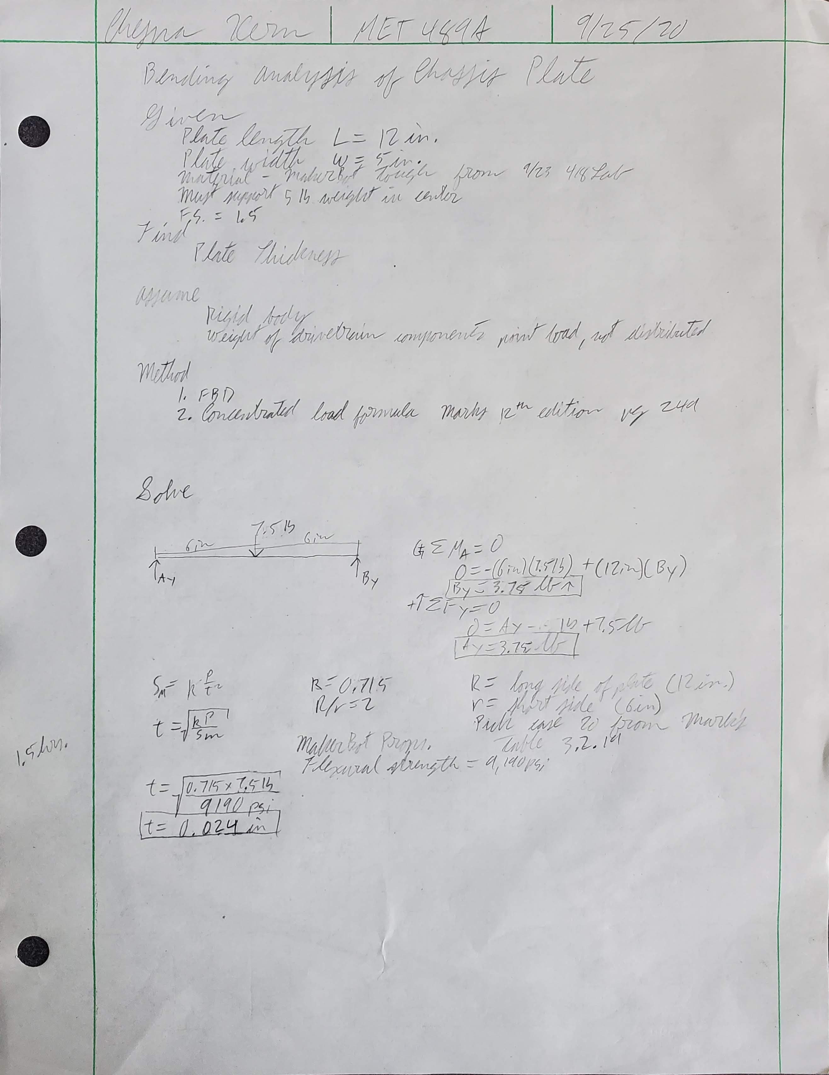
Appendix A-1 – Flat Plate Load Analysis
Bending analysis of the chassis plate approximated by a rectangular plate.

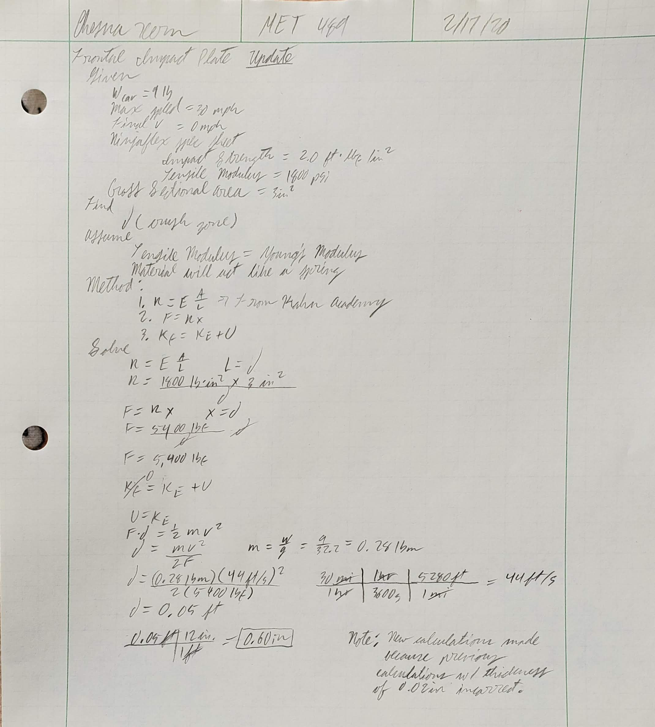
Appendix A-2 – Analysis of Front Bumper as a Spring
Conservation of energy and Hooke’s law used to determine bumper thickness.

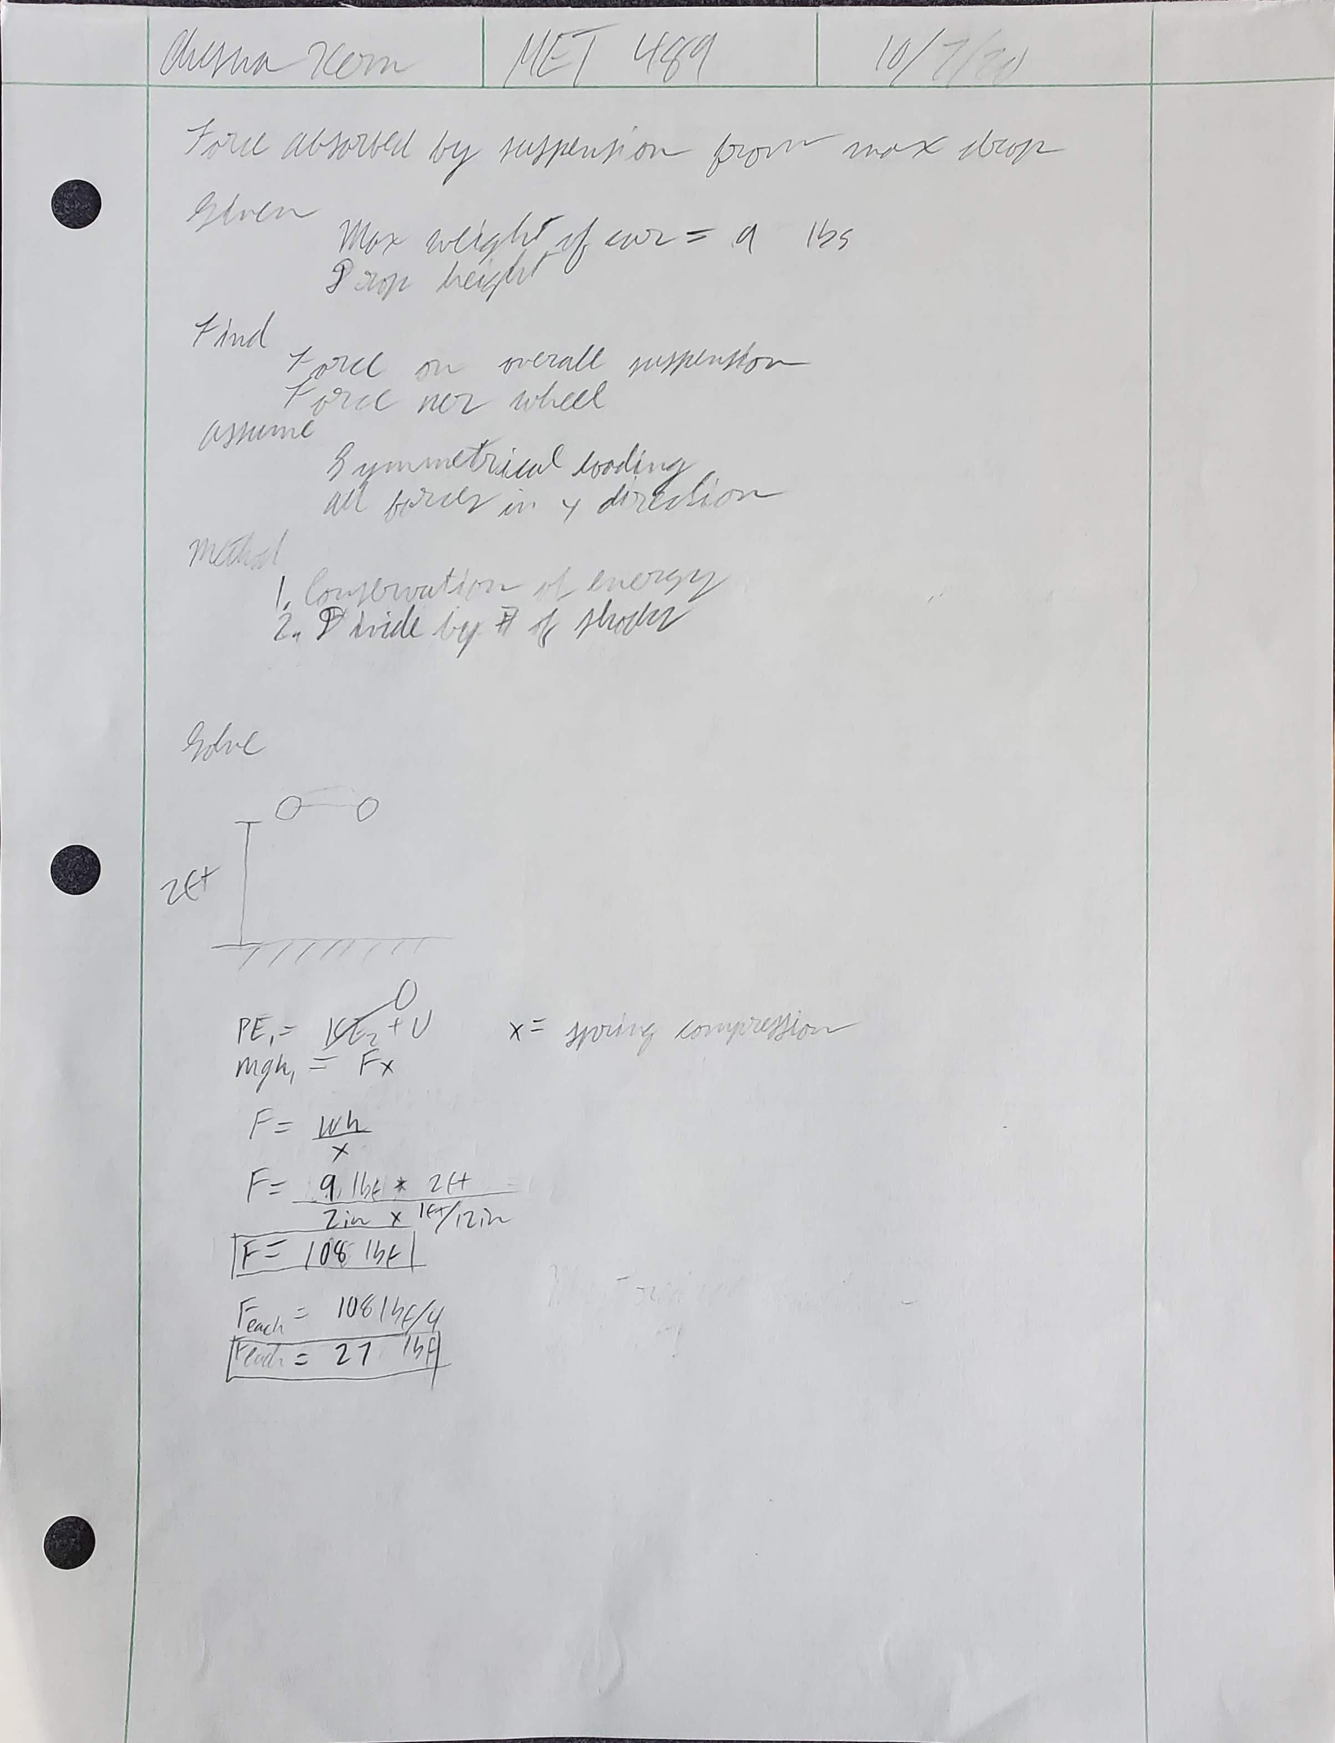
Appendix A-3 – Max Force Absorbed by Suspension
Conservation energy used to determine force on each shock.

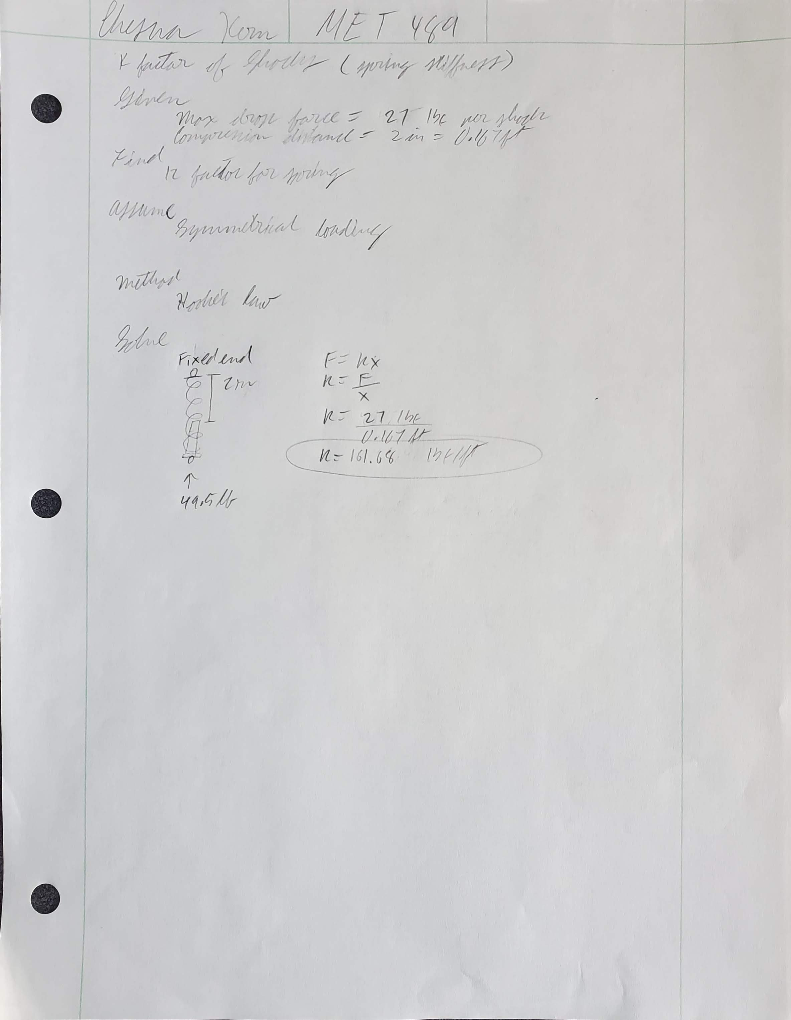
Appendix A-4 – Shock K Factor
Hooke’s law used to determine the spring stiffness necessary to absorb max impact.

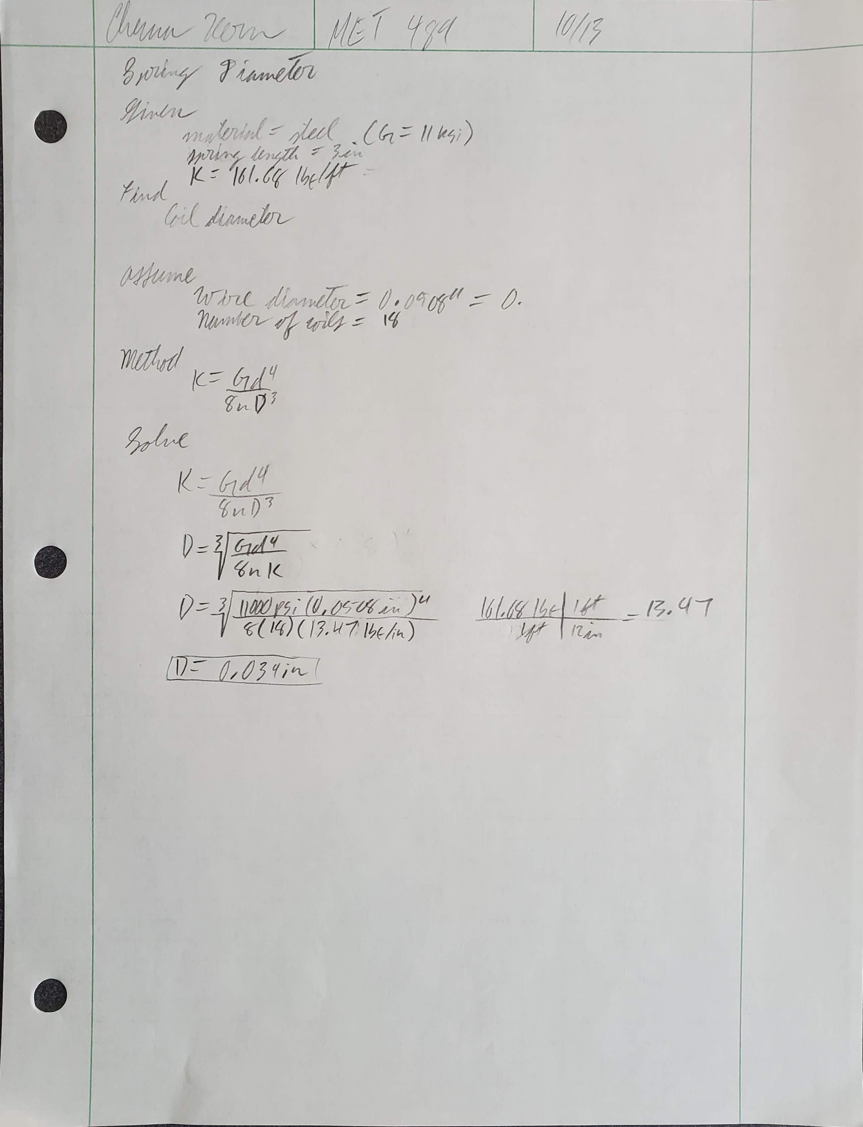
Appendix A-5 – Shock Spring Diameter
The spring force equation was used to determine the minimum diameter of the shock springs.

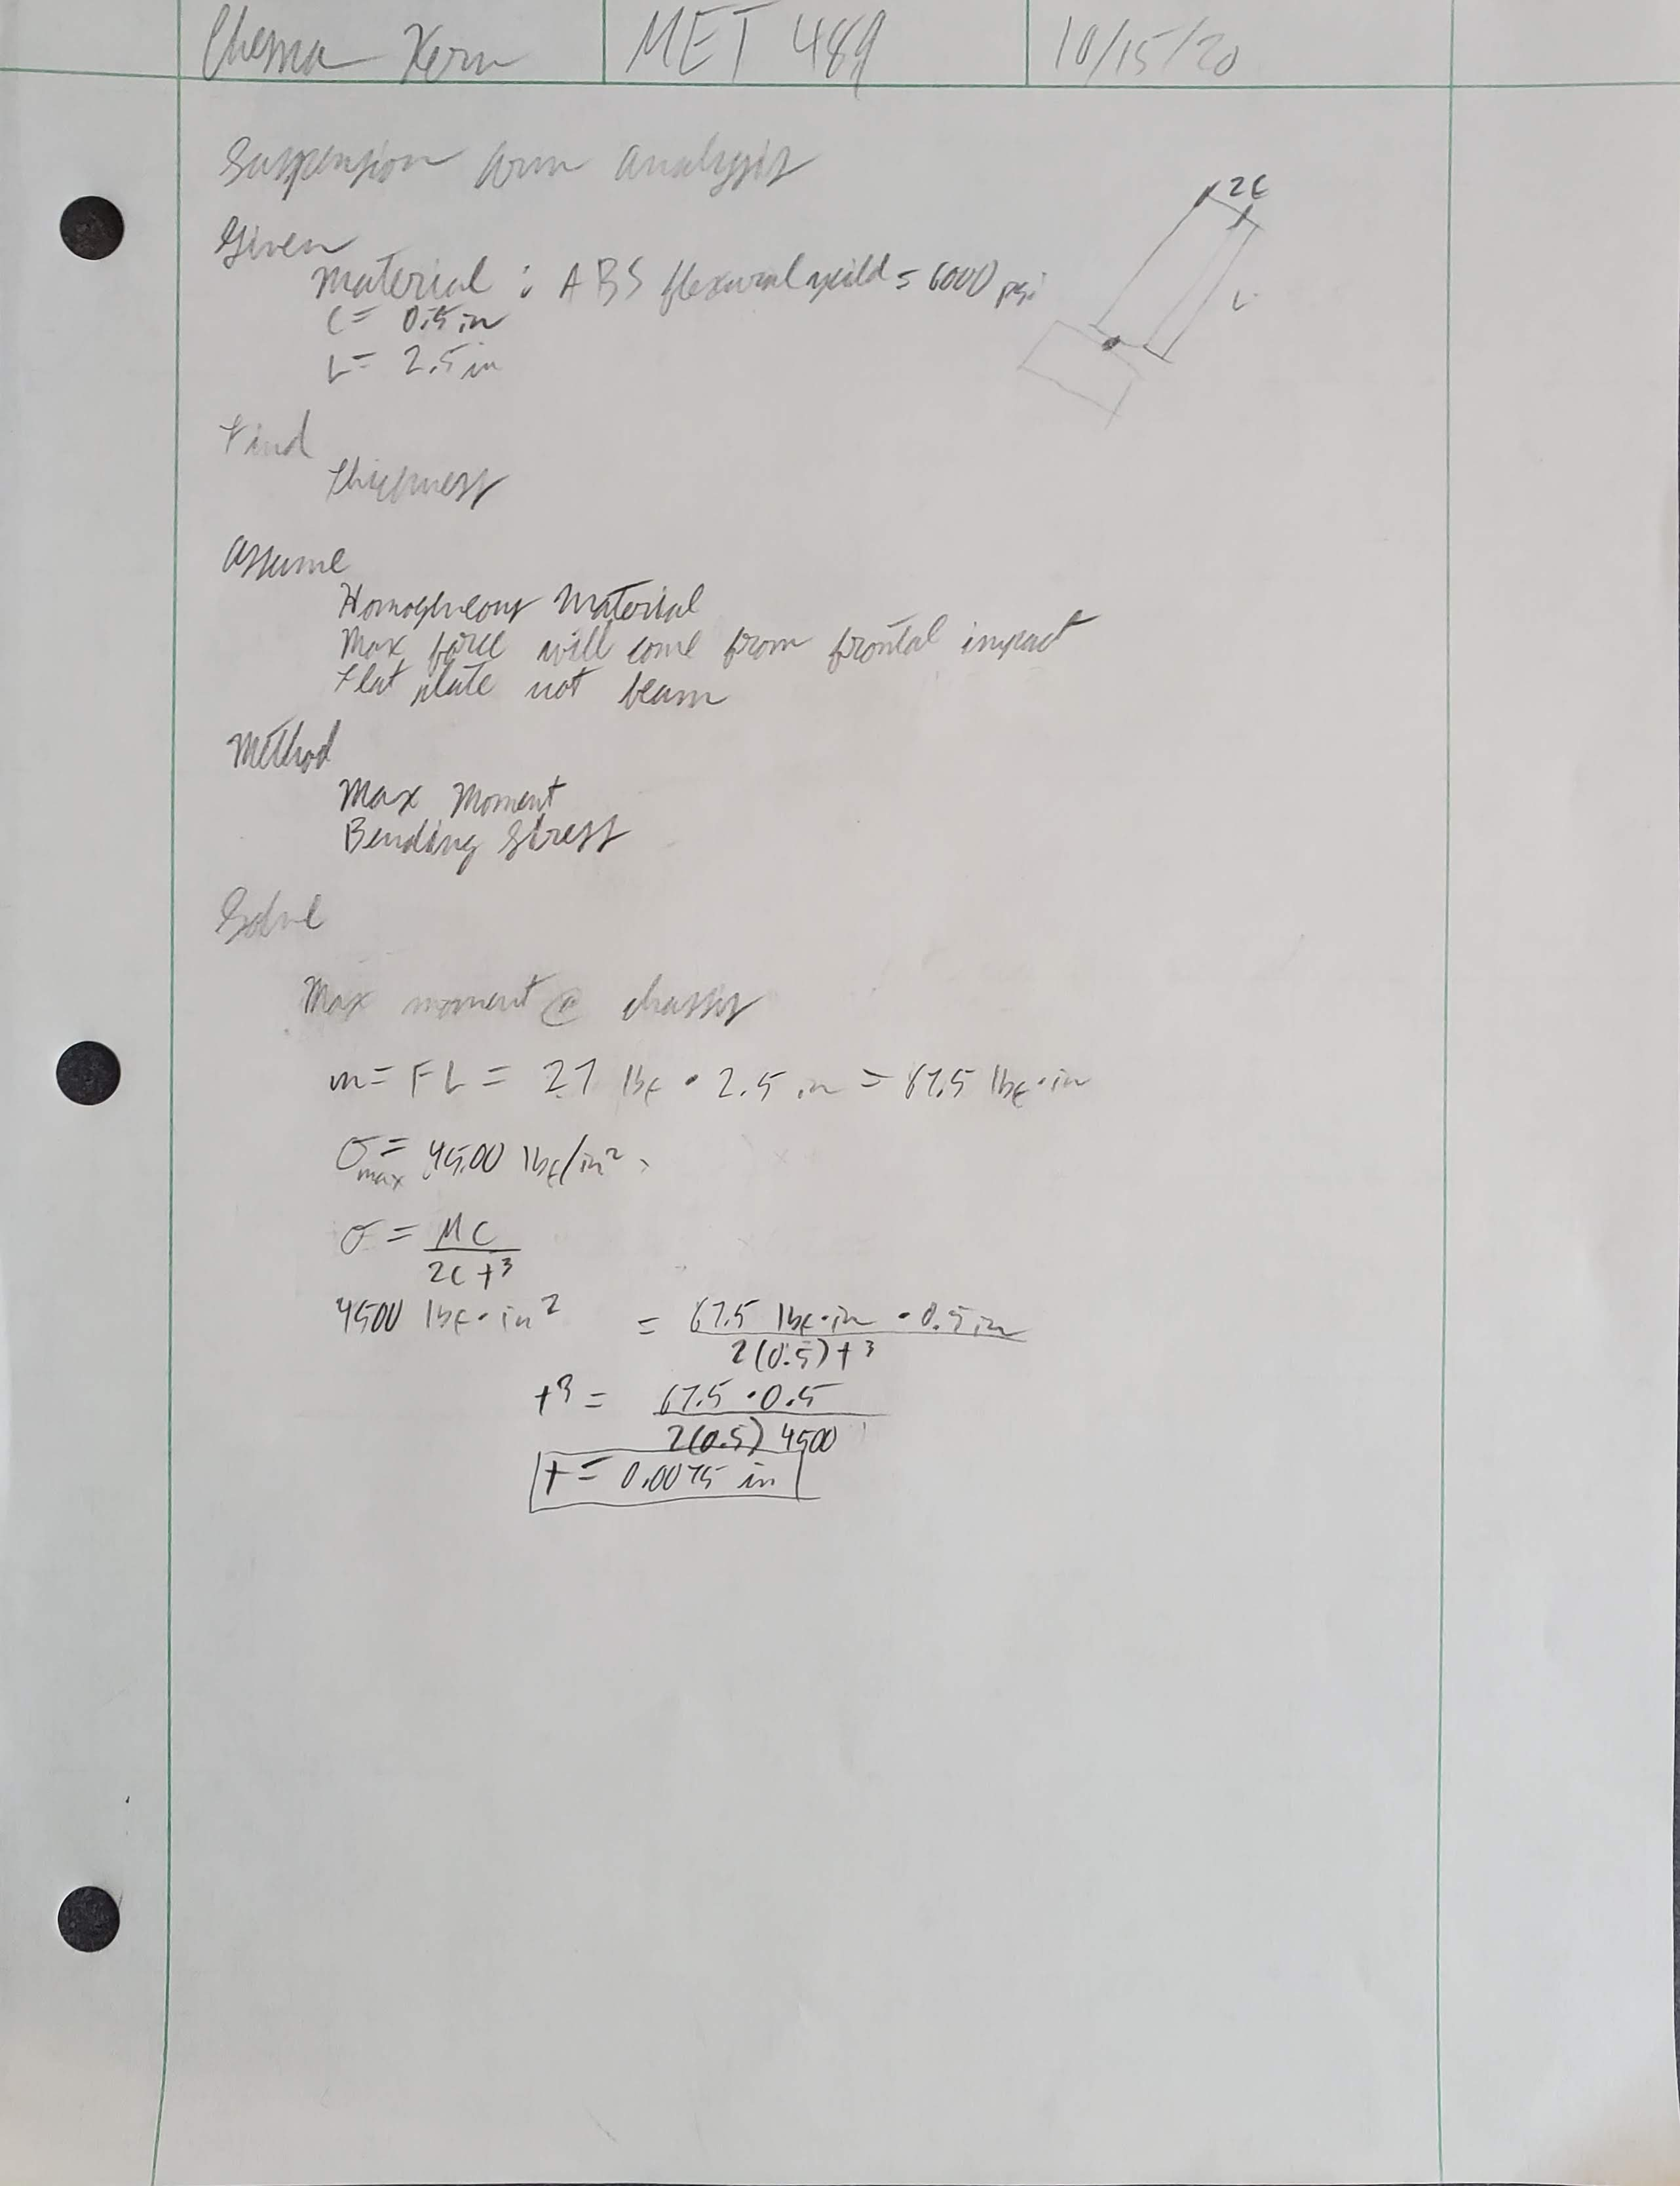
Appendix A-6 – Suspension Arm Thickness
The bending stress equation was used to determine a necessary thickness of 0.0075 inches.

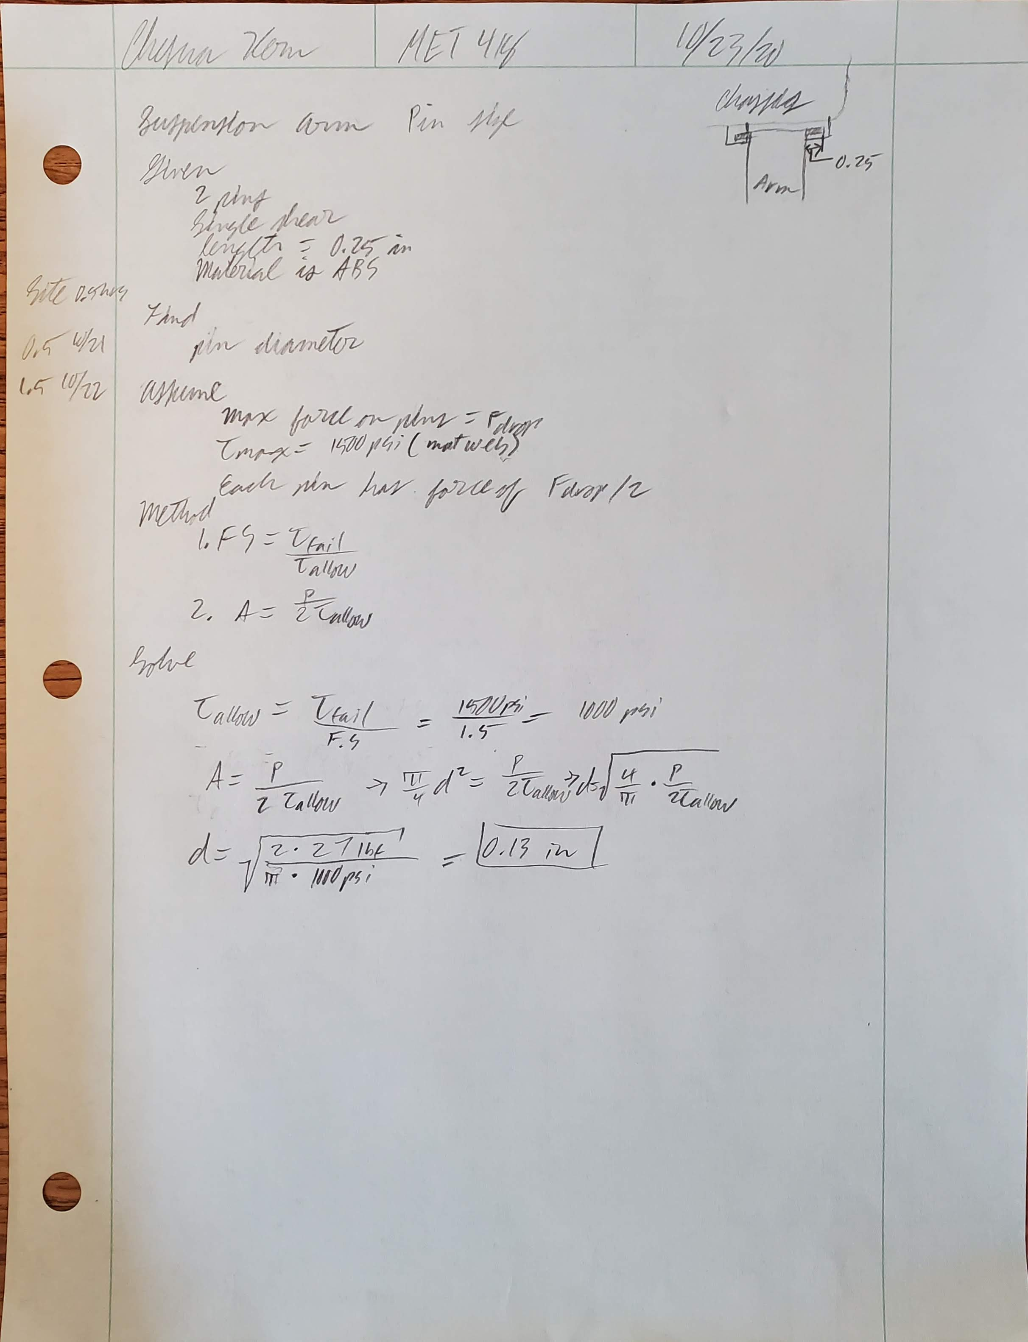
Appendix A-7 – Suspension Arm Pin Size
Shear stress was used to determine the diameter of the pin to be 0.13 inches.

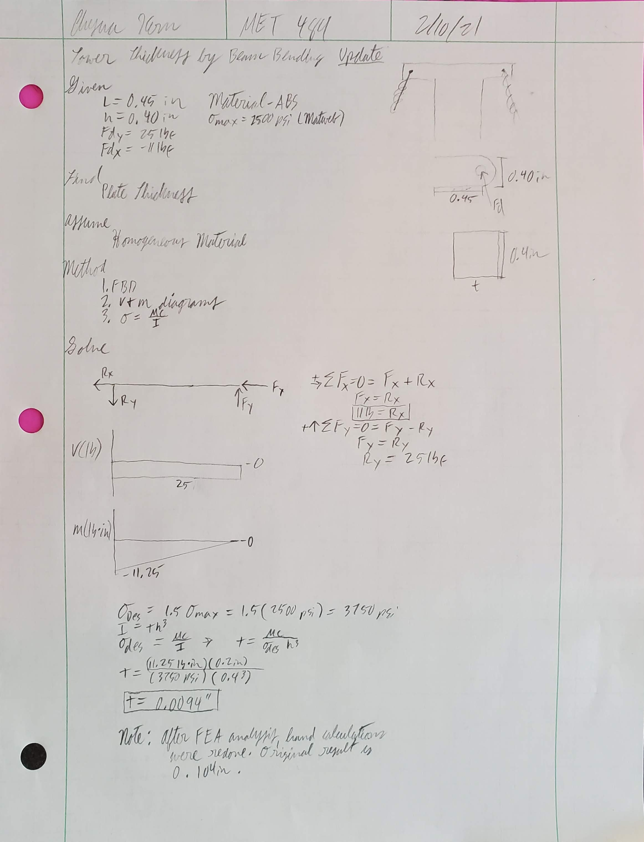
Appendix A-8 – Tower Thickness
Bending stress was used to determine the minimum tower thickness to be 0.104 inches.

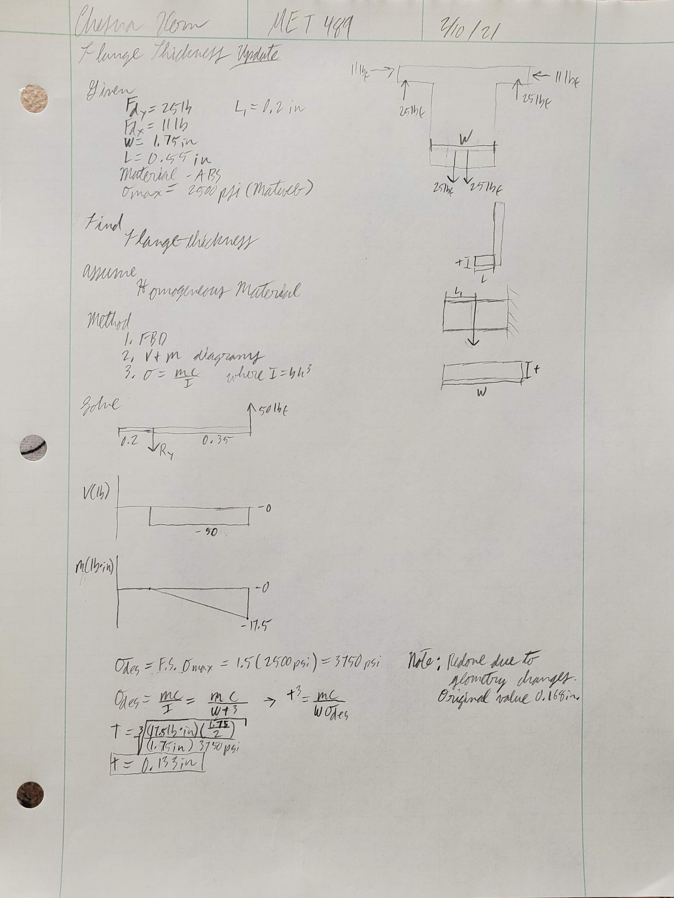
Appendix A-9 – Suspension Tower Flange Thickness
Bending stress was used to determine the minimum flange thickness to be 0.168 inches.

Appendix A-10 – Suspension Arm Pin Size
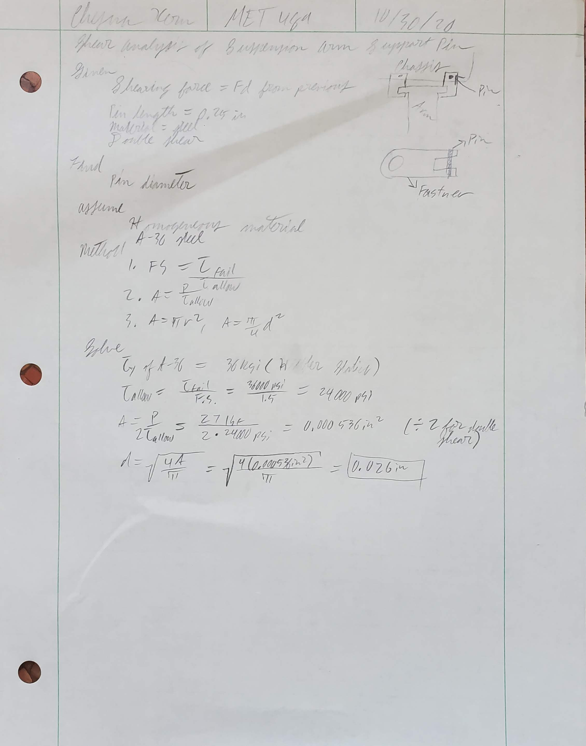
Bending stress was used to determine the minimum pin thickness to be 0.026 inches.

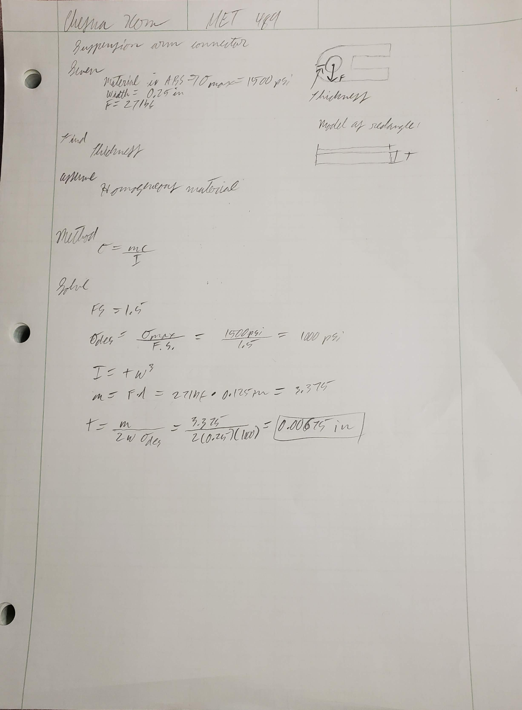
Appendix A-11 – Suspension Arm Fastner Shear Analysis
Bending stress was used to determine the minimum thickness of the round part of the fastener.

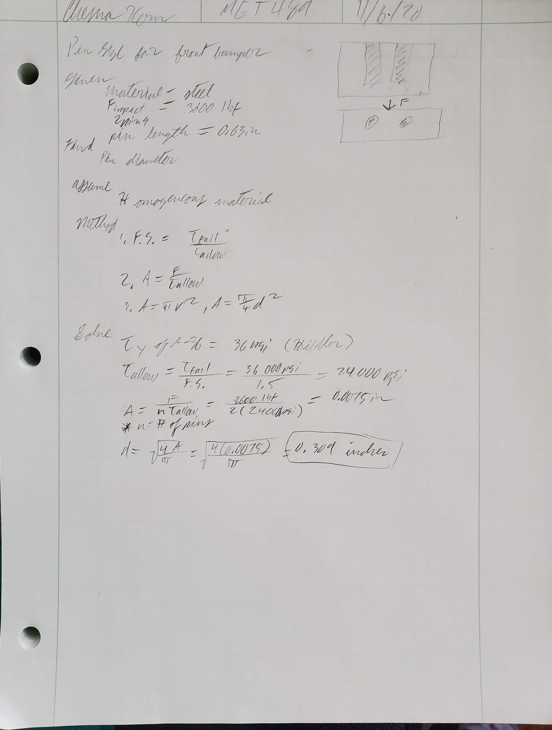
Appendix A-10 – Suspension Arm Fastner Shear Analysis
Shear stress was used to determine the minimum pin thickness.

APPENDIX B - Drawings

Appendix B – Drawing Tree

Appendix B – Full Assembly
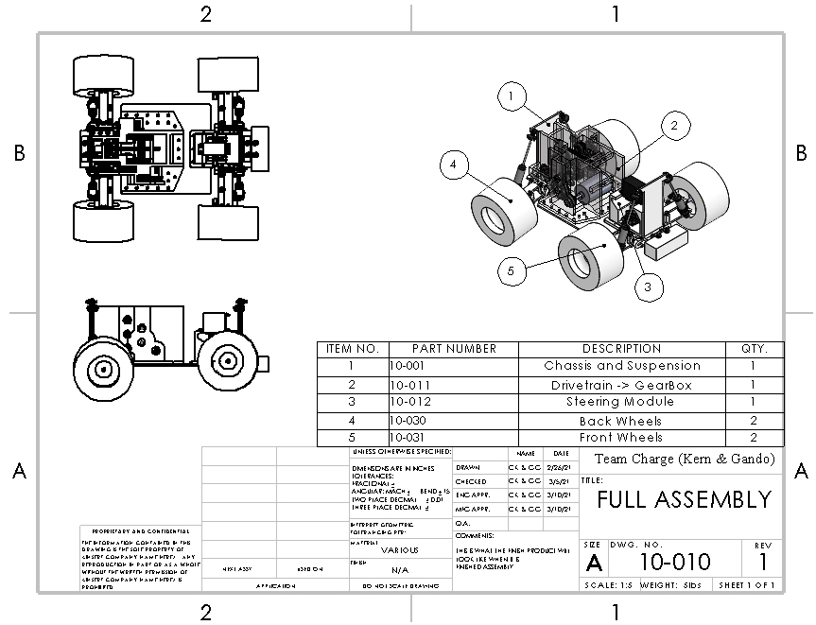
Drawing of assembly with drivetrain, chassis, and suspension.

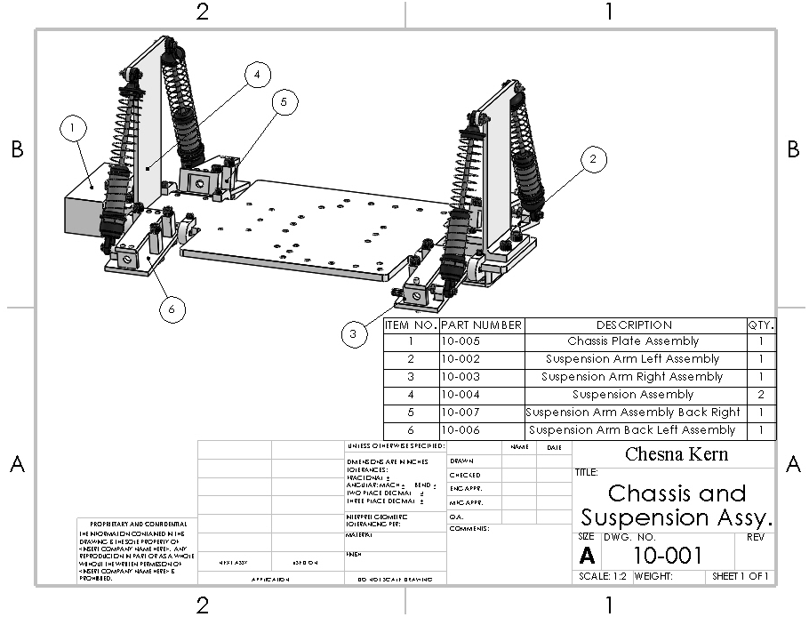
Appendix B – Chassis and Suspension Assembly

High level assembly of the chassis.

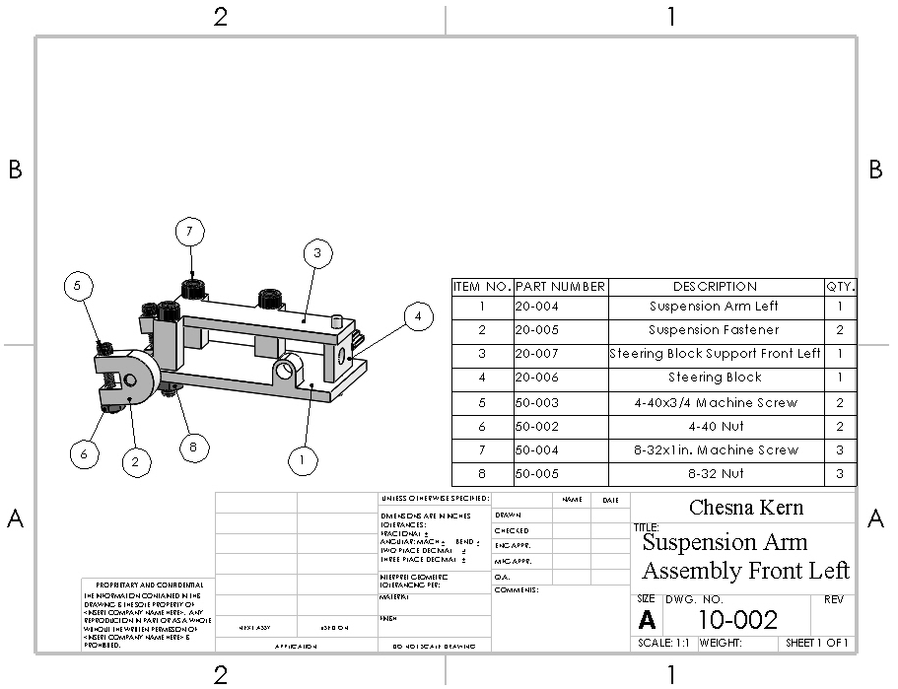
Appendix B – Suspension Arm Front Left Subassembly

The front left suspension arm subassembly.

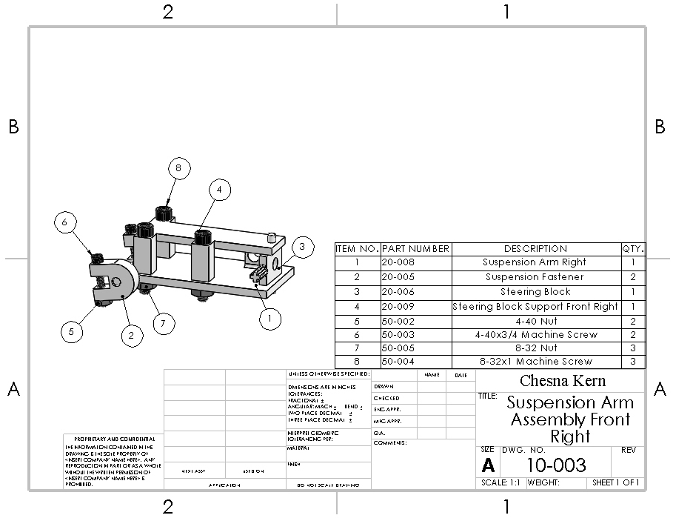
Appendix B – Suspension Arm Front Right Subassembly

The right front suspension arm assembly.

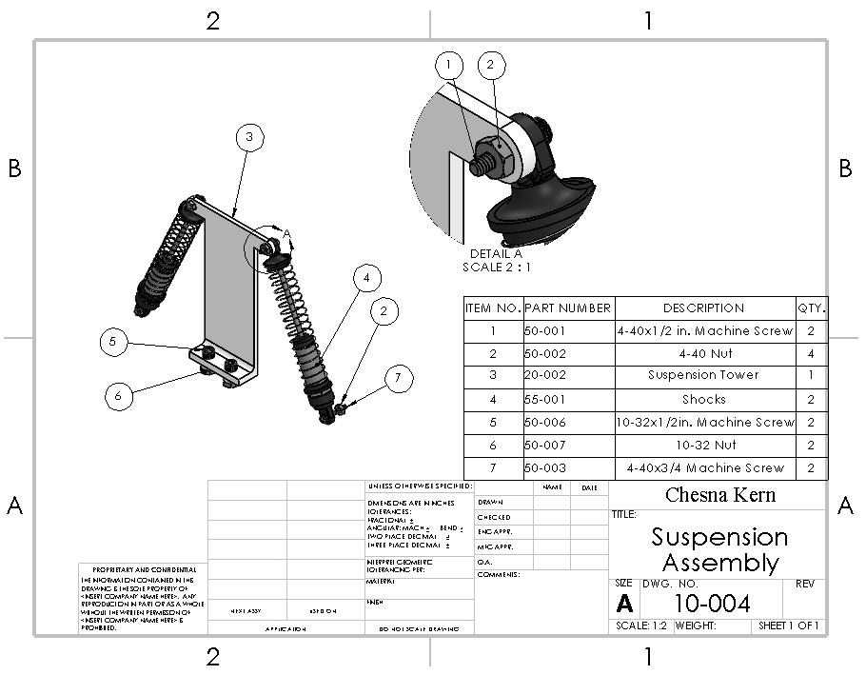
Appendix B – Suspension Subassembly
The suspension assembly which includes the suspension tower and shocks.

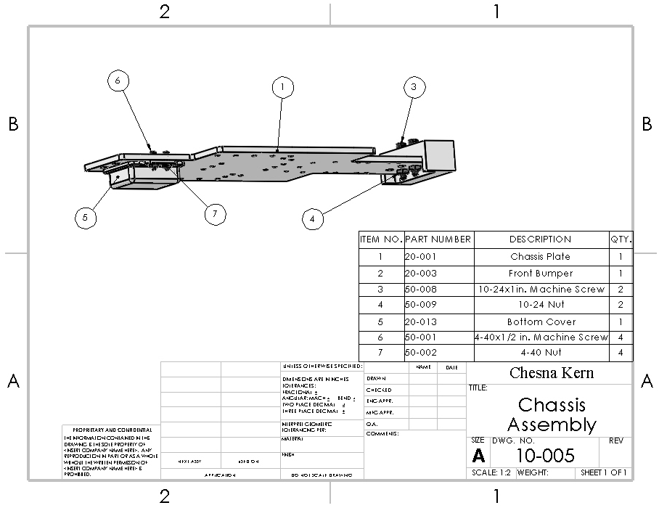
Appendix B – Chassis Subassembly
Subassembly of chassis plate, front bumper, and bottom cover.

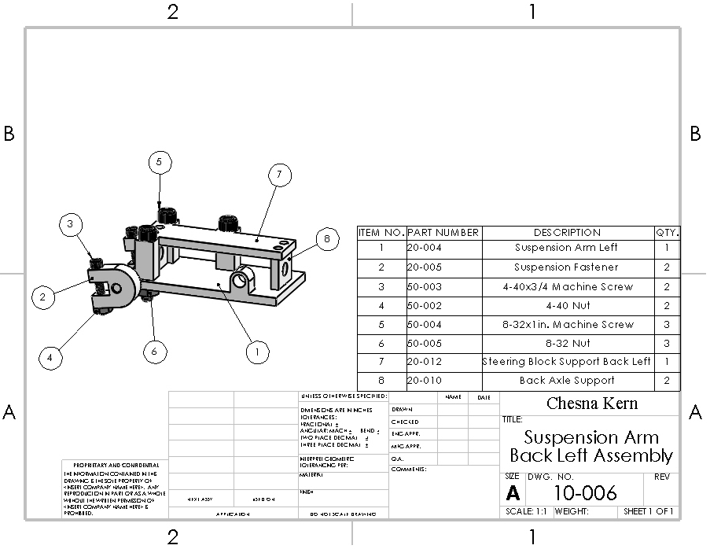
Appendix B – Suspension Arm Back Left Subassembly

Drawing of the back left suspension arm subassembly.

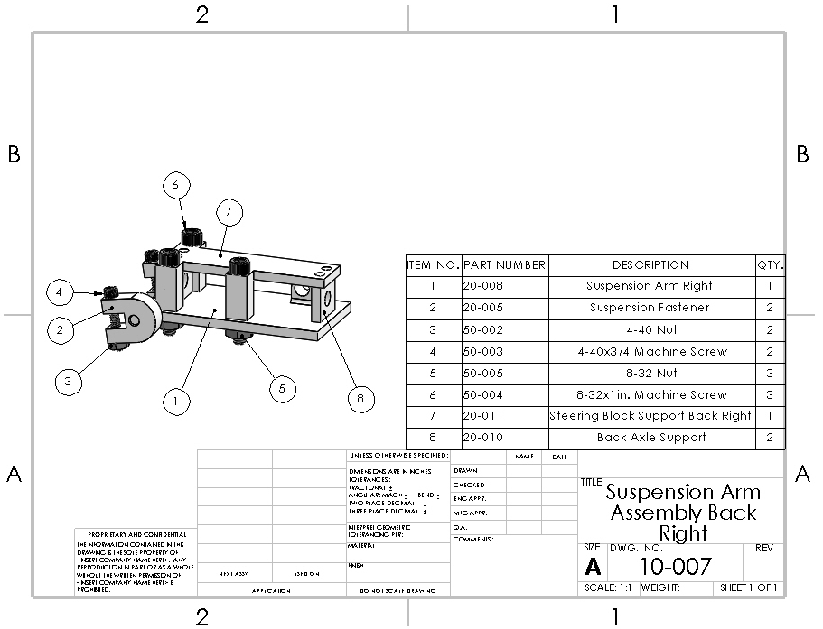
Appendix B – Suspension Arm Back Right Subassembly
Drawing of the back right suspension arm subassembly.

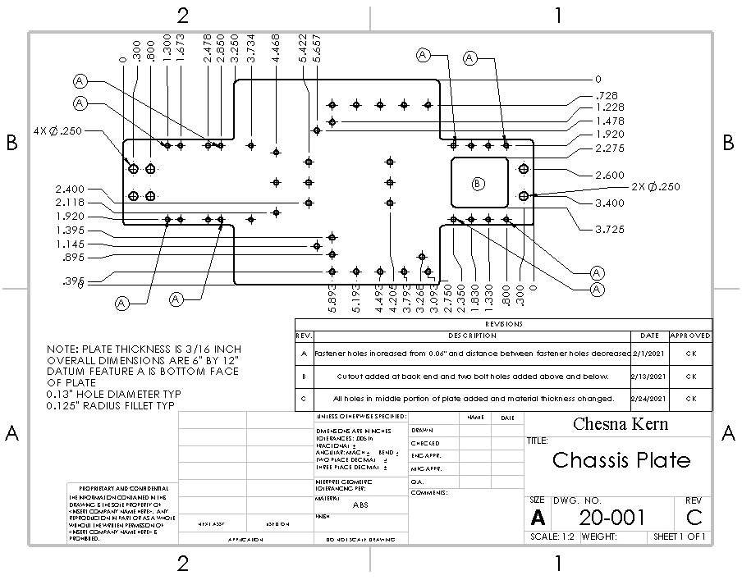
Appendix B – Chassis Plate
Drawing of chassis plate.

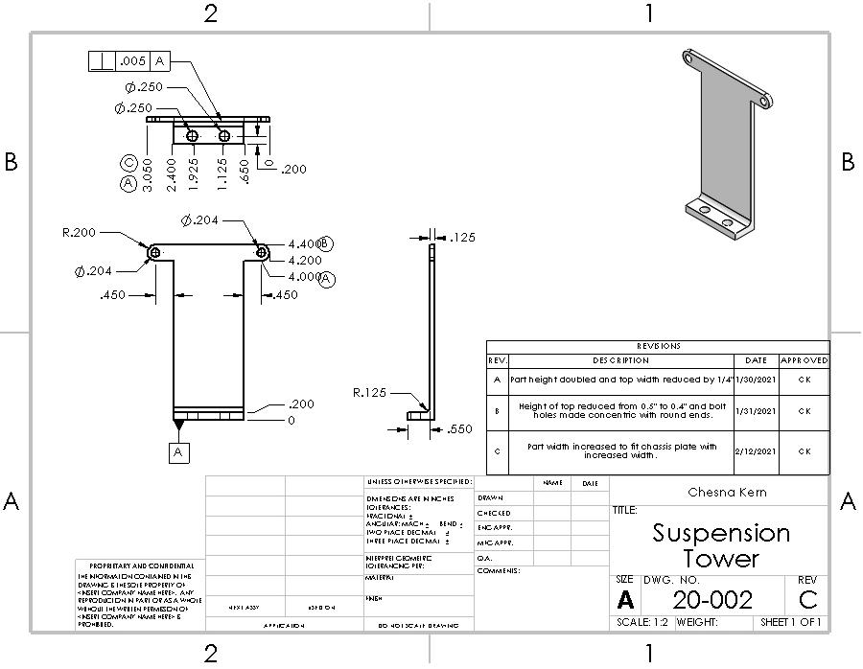
Appendix B – Suspension Tower
Drawing of suspension tower.

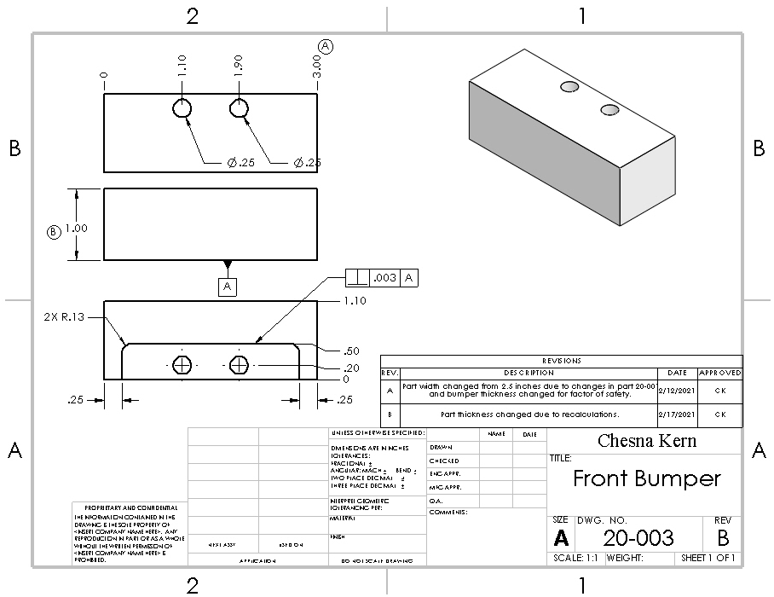
Appendix B – Front Bumper
Drawing of front bumper.

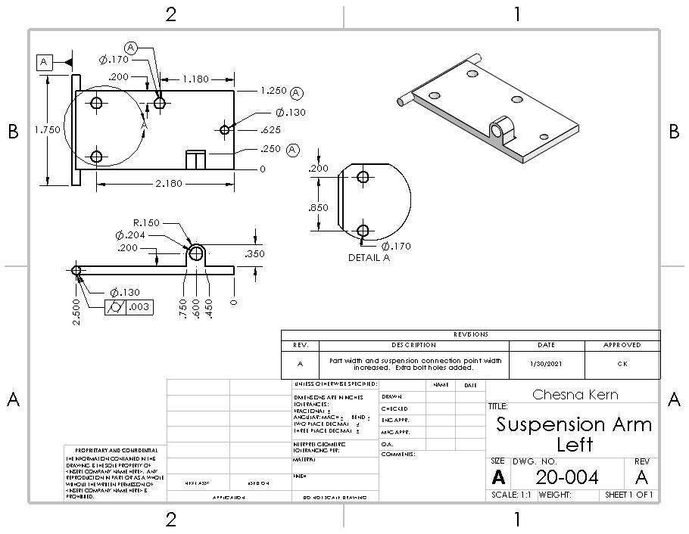
Appendix B – Suspension Arm
Drawing of left suspension arm.

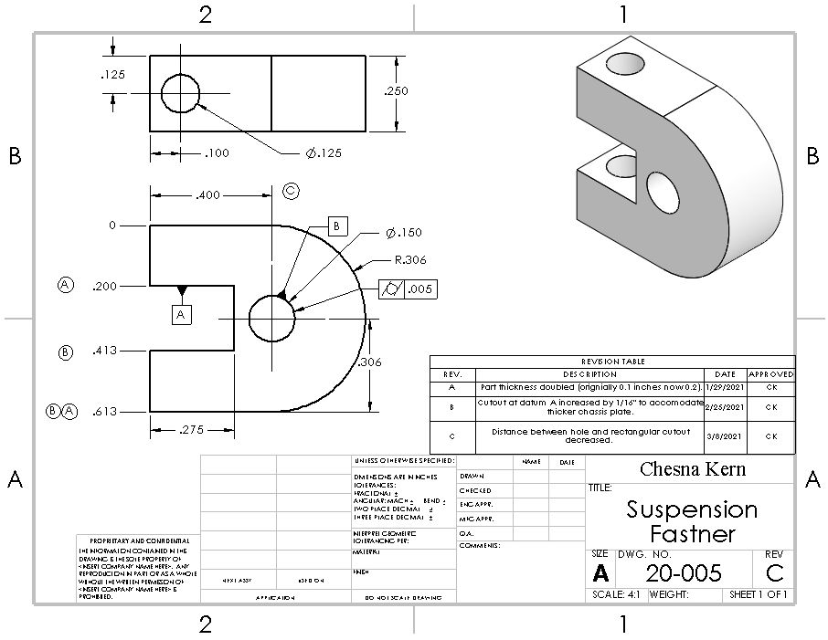
Appendix B – Suspension Fastener
Drawing of suspension fastener.

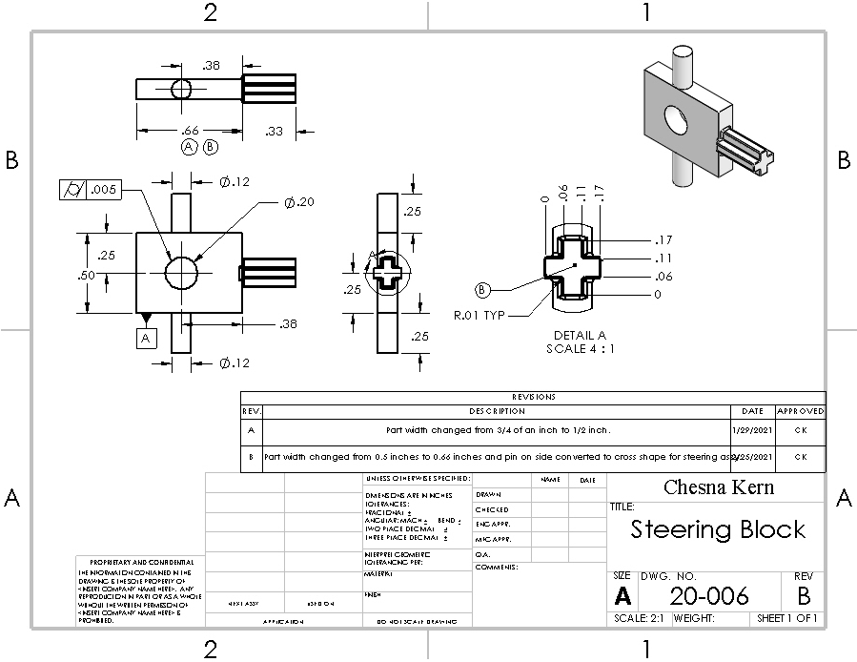
Appendix B – Steering Block

Drawing of the steering block.

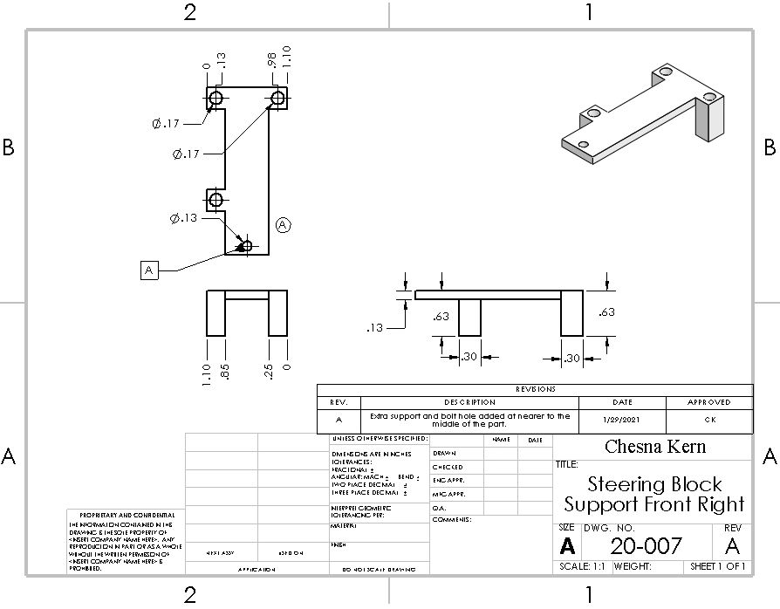
Appendix B – Steering Block Support
Drawing of the steering block support with the extra support on the right.

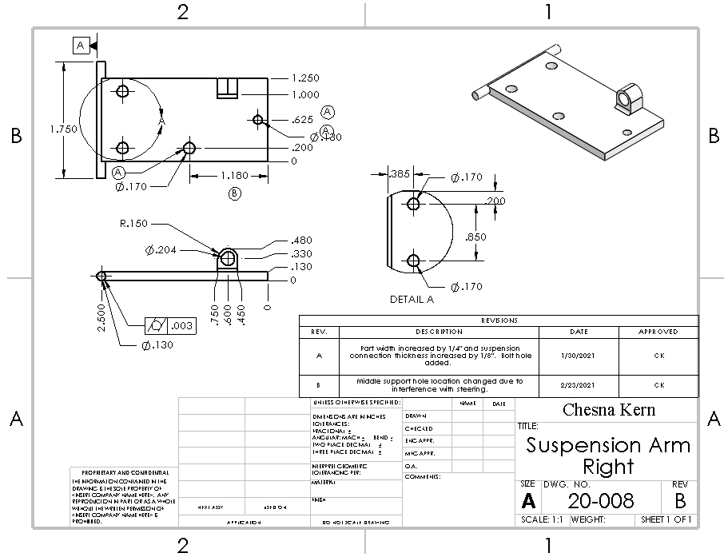
Appendix B – Suspension Arm Right
Drawing of the right side version of the suspension arm.

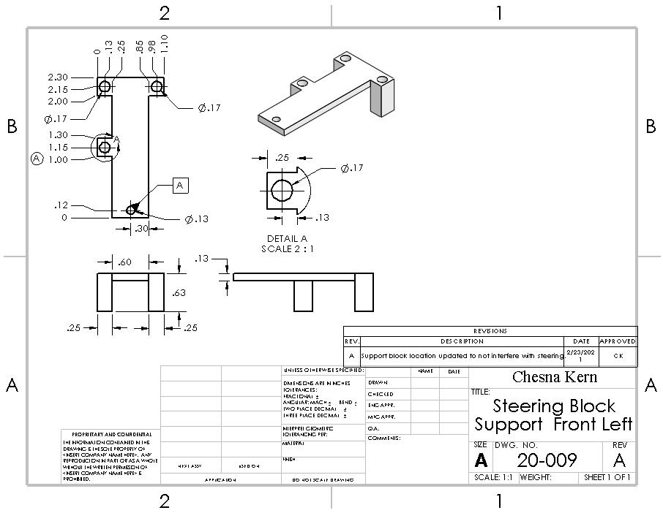
Appendix B – Steering Block Support Left
Drawing of the version of the steering block support with the third support on the left.

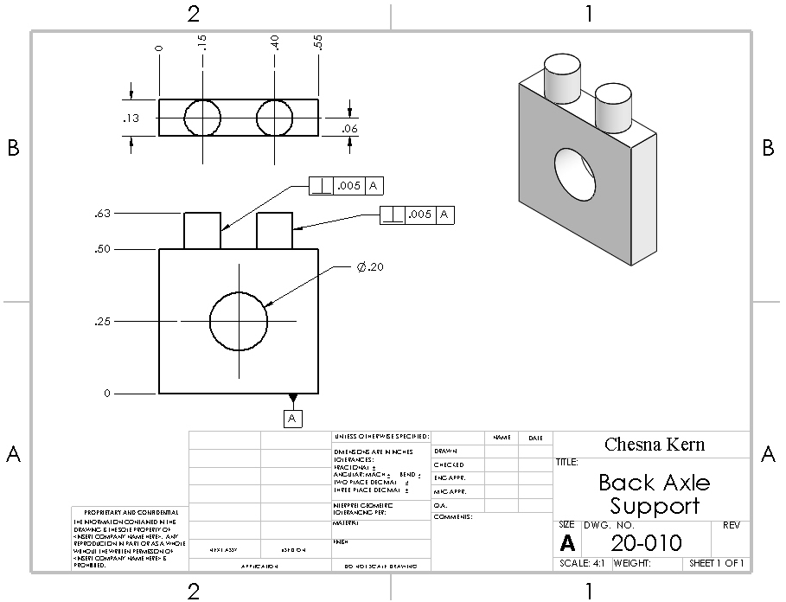
Appendix B – Back Axle Support

Drawing of the extra support for the back axle.

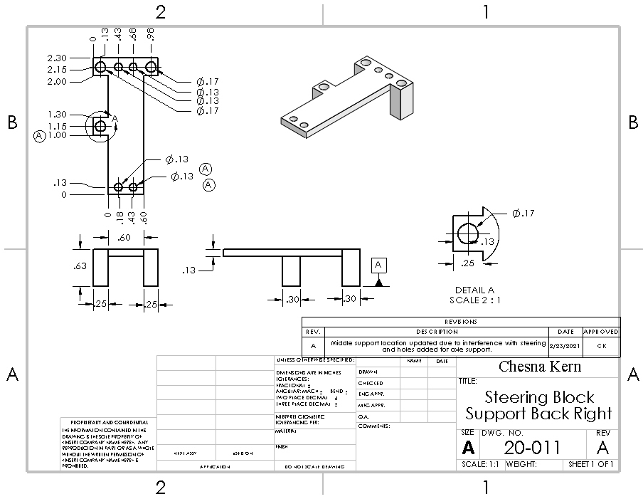
Appendix B – Steering Block Support Back Right
Drawing of the back right steering block.

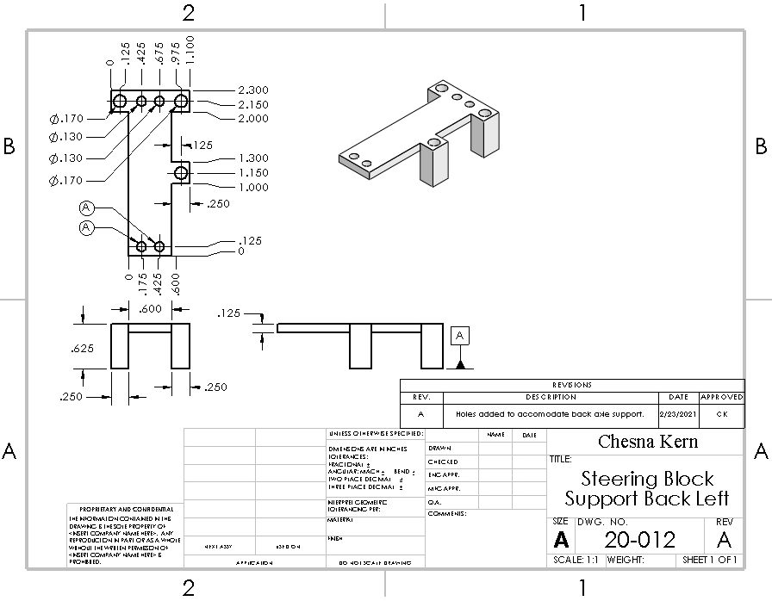
Appendix B – Steering Block Support Back Left
Drawing of the back left steering block.

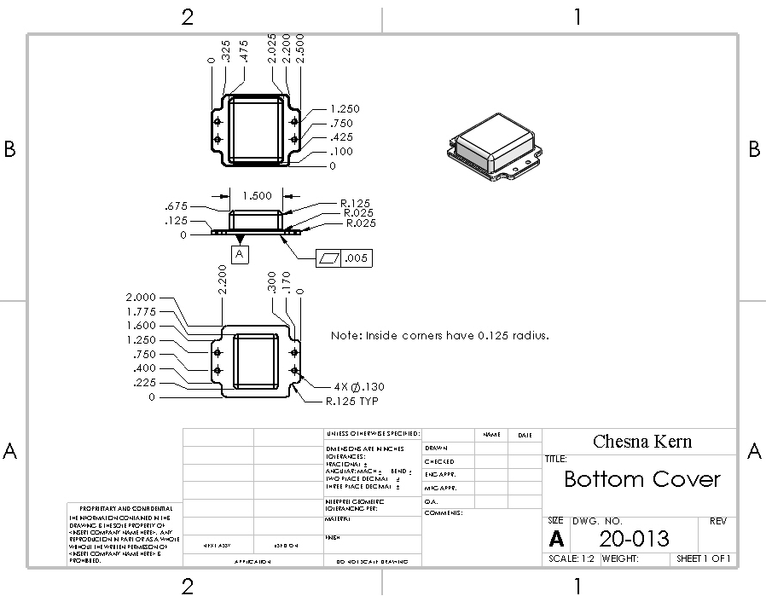
Appendix B – Bottom Cover
Drawing of the back right steering block.

APPENDIX C – Parts List and Costs

Part Number | Qty | Part Description | Source | Cost/ea | Disposition
20-001 | 1 | Chassis Plate | Laser cut acrylic sheet | $23 | Order in January
20-002 | 2 | Suspension Tower | 3D Print ABS | $0.25 | Printed
20-003 | 1 | Front Bumper | 3D Print NinjaFlex | $3 | Printed
20-004 | 2 | Suspension Arm Left | 3D Print ABS | $0.20 | Printed
20-005 | 8 | Suspension Fastener | 3D Print ABS | $0.15 | Printed
20-006 | 2 | Steering Block | 3D Print ABS | $0.15 | Printed
20-007 | 1 | Steering Block Support Front Right | 3D Print ABS | $0.18 | Printed
20-008 | 2 | Suspension Arm Right | 3D Print ABS | $0.20 | Printed
20-009 | 1 | Steering Block Support Front Left | 3D Print ABS | $0.18 | Printed
20-010 | 4 | Back Axle Support | 3D Print ABS | $0.15 | Printed
20-011 | 1 | Steering Block Support Back Right | 3D Print ABS | $0.18 | Printed
20-012 | 1 | Steering Block Support Back Left | 3D Print ABS | $0.18 | Printed
20-013 | 1 | Bottom Cover | 3D Print ABS | $0.25 | Printed
50-001 | 4 | 4-40x1/2 Machine Screw | Local Hardware Store | $0.07 | Order as needed
50-002 | 16 | 4-40 Nut | Local Hardware Store | $0.06 | Order as needed
50-003 | 12 | 4-40 x3/4 Machine Screw | Local Hardware Store | $0.07 | Order as needed
50-004 | 12 | 8-32x1 Machine Screw | Local Hardware Store | $0.10 | Order as needed
50-005 | 12 | 8-32 Nut | Local Hardware Store | $0.07 | Order as needed
50-006 | 4 | 10-32x1/2 Machine Screw | Local Hardware Store | $0.10 | Order as needed
50-007 | 4 | 10-32 Nut | Local Hardware Store | $0.07 | Order as needed
50-008 | 2 | 10-24x1 Machine Screw | Local Hardware Store | $0.12 | Order as needed
50-009 | 2 | 10-24 Nut | Local Hardware Store | $0.07 | Order as needed
55-001 | 4 | Shocks | Amazon | $6.75 | Order in December
55-002 | 4 | 4” Wheels with hubs | ASME | $0 | Donated by ASME in October

APPENDIX D – Budget

Item | Qty | Description | Cost (total)
ABS Filament | 1 | Raw material for parts 20-002 to 20-013 | $40
ABS Sheet | 1 | Raw material for part 20-001. | $40
Assorted Screws | 20 | Screws used to hold car together. | $30
Assorted Nuts | 20 | Nuts for assembly screws | $30
Shocks | 4 | Spring suspension for front and back. | $25
Wheels | 4 | 4” wheels for vehicle, donated by ASME. | $0

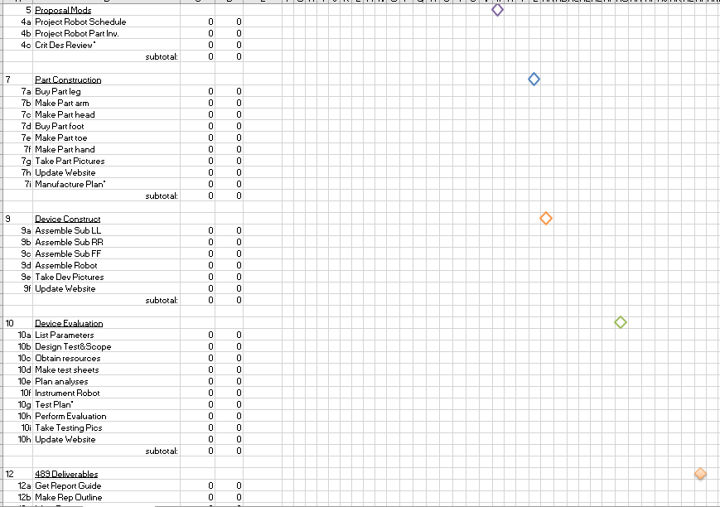
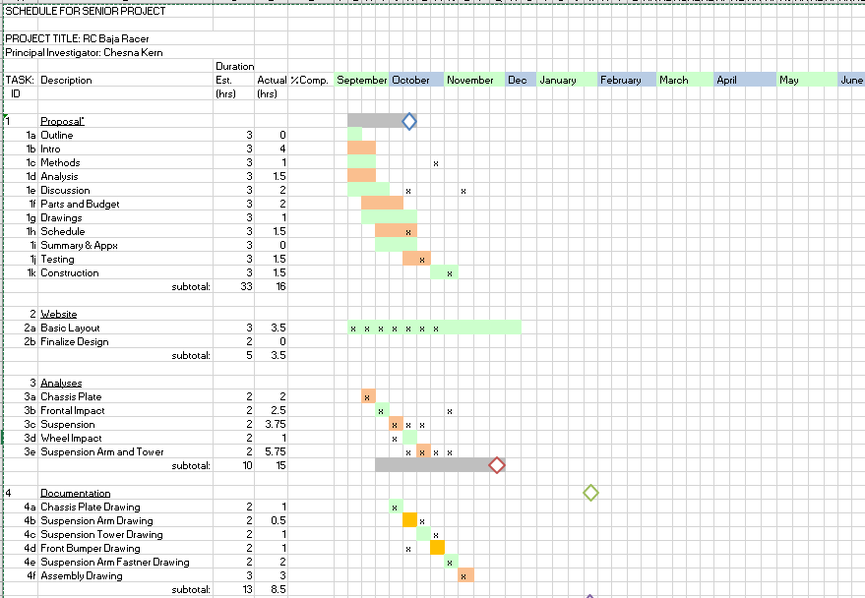
APPENDIX E - Schedule
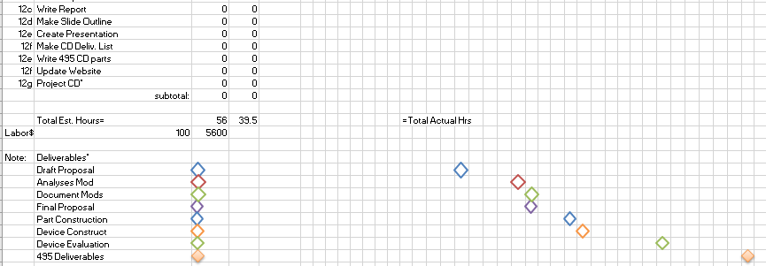

Appendix F – Expertise and Resources
Assistance was needed from Phil Kern and Lynn French for use of a 3d printer and laser cutter.

APPENDIX G – Testing Report

Appendix H – Resume


